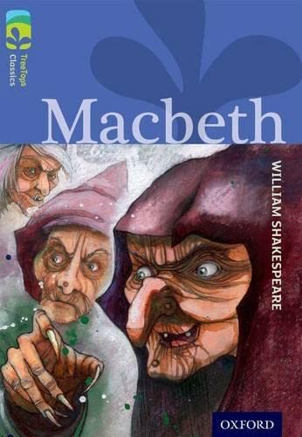
Purpose, Audience and Register
Purpose = The purpose is to perform the ‘Witches’ Spell’ from Macbeth in order to entertain and deliberately foreshadow future events which will engage the reader.
Audience = The audience are Macbeth enthusiasts who would watch a theatre production of the play.
Levels of Formality = An informal register is required to capture the colloquialisms of the poem and the characters of the witches.
Crofton Junior School
Unit of Work | The Witches’ Spell Poem
Text Type / Genre | Performance Poetry
Text Driver the Unit of Work links to | Macbeth by William Shakespeare
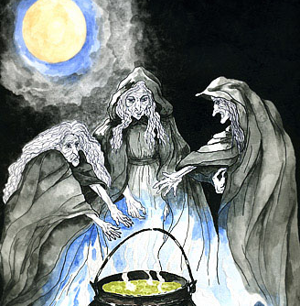
English Knowledge Organiser Year 6 Spring 1 Unit 1

Overview of the Unit of Work including End of Unit Outcome | Children will initially listen to the poem being read aloud and they will focus on the 6 Ps of performance reading: pace, personality, pitch, punctuation, power and pauses. They will particularly focus on the rhyming couplets and how they impact the pace and rhythm of the poem. Prior to learning the poem by heart and performing this, pupils will explore that the poem is a recipe for trouble, prophesising the issues that will arise in the future for Macbeth. They will discover the meaning of key ‘ingredients’ and other words within the poem such as ‘entrails’, ‘toil’, ‘fenny snake’ and ‘hell-broth’ which will support them to understand the hideous nature of the magical potion and the tremendous power and wickedness of the witches. Pupils will then apply their knowledge of the 6Ps and the meaning of the poem to learn the Witches’ Spell by heart and they will demonstrate their understanding through intonation, tone and volume so that meaning is clear to the audience. Pupils will perform the spell to their peers and provide positive and constructive feedback for one another in order to enable them to refine their performances further.
Links to Reading Objectives | Pupils will apply their knowledge of the 6Ps of performance reading in order to prepare the Witches’ Spell to read aloud and to perform, showing understanding through intonation, tone and volume so that the meaning is clear to an audience. Pupils will discuss their understanding and explore the meaning of words in context so that the poem makes sense which will support them with their performance ensuring that appropriate words are emphasised and that actions are used effectively to capture the characters’ personalities and power.
Prior Learning | Text Type - Performance Poetry  - In Year 3 in the autumn term, pupils explored the poem ‘The Sound Collector’ by Roger McGough and its key messages before applying their knowledge of the 6Ps to read this aloud.  - In Year 3 in the summer term, pupils created a shape poem inspired by volcanoes to entertain and engage an audience when performed.  - In Year 4 in the summer term, pupils performed a selection of poems from the following text: Poems to Perform.  - In each year group, pupils explore performance poetry as part of their fluency and performance reading sessions at least once every term.
Text Type Features  (Poetry) | - There are many different types of poems: acrostic, cinquain, free verse, shape, nonsense, limerick, haiku and narrative.  - Poems can rhyme. Words that rhyme have the same sound and rhyming poems can be written using pairs (rhyming couplets) or groups of words that use the same sound.  - Poems can be written in verses based around themes and ideas.  - Descriptive language that creates imagery (a picture in the mind of the reader) is important in poetry. Poems often include descriptive devices like: Similes: they describe something by comparing it to something else, using like or as. Metaphors: they are a word or a phrase used to describe something as if it were something else. Personification: it describes objects as if they are people.
Sticky Knowledge | The children will learn:  - Poems can rhyme and this poem has been written using pairs (rhyming couplets) that use the same sound to support rhythm throughout the poem.  - Poetry should be read in a way that reflects on rhyme and punctuation in order for appropriate intonation, tone, volume and actions to be used.  - The purpose of the poem is to emphasise the power and wickedness of the three witches through their creation of a ‘hell-broth’: a brew for black (evil and corrupt) magic.  - The Witches’ Spell is a recipe for trouble which prophesises the issues that will arise in the future for Macbeth within the play by Shakespeare.
New Vocabulary | - Entrails – a person’s or animal’s intestines or internal organs especially when removed or exposed  - Sweltered – uncomfortably hot  - Toil – work extremely hard  - Fenny snake – a type of snake in the magical world  - Hell-broth – a brew for black magic  - Prophecy – a prediction of what will happen in the future
Post Learning | - In Key Stage 3, pupils will improvise, rehearse and perform play scripts and poetry in order to generate language and discuss language use and meaning, using role, intonation, tone, volume, mood, silence, stillness and action to add impact.  - In Key Stage 3, pupils will continue to develop an appreciation and love of reading by reading a wide range of poems and plays with a wide coverage of genres, historical periods, forms and authors. The range will include high-quality works from Shakespeare (two plays).

