Crofton Junior School – Curriculum Knowledge Organiser
Unit of Work | Science – Biology – Year 6
Key Strand | Investigate Evolution and Inheritance
Overview of the Unit of Work | This concept involves understanding that organisms come into existence, adapt, change and evolve and become extinct.
Prior Learning & Vocabulary | Year 2: suited/suitable  Year 3: fossils
Sticky Knowledge | Offspring: Animals and plants produce offspring that are similar but not identical to them. Offspring often look like their parents because features are passed on.  Variation: In the same way that there is variation between parents and their offspring. You can see variation within any species, even plants.  Adaptive traits: Characteristics that are influenced by the environment the living things in. There adaptations can develop as a result of many things, such as food and climate.  Inherited traits: Eye colour is an example of an inherited trait, but so are characteristics like hair colour, the shaped of your earlobes and whether or not you can smell flowers.  Environments: There are many types of environments around the world. Polar regions, deserts, rainforests, oceans, rivers and grasslands are all environments. Animals have particular adaptive traits for the environments.  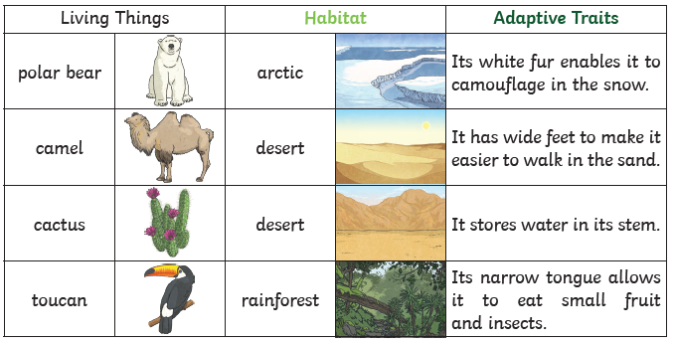  - Natural selection: the process whereby organisms better adapted to their environment tend to survive and produce more offspring. The theory of its action was first fully expounded by Charles Darwin, and it is now regarded as be the main process that brings about evolution. Example: Fossils of giraffes from millions of years ago show that they used to have shorter necks. They have gradually evolved though natural selection to have longer necks so that they can reach the top leaves on taller trees.
 | Fossils are the preserved remains, or partial remains, of ancient animals and plants. Fossils let scientists know how plants and animals used to look millions of years ago. This is proof that living things have evolved over time. Evolution is the gradual process by which different kinds of living organism have developed from earlier forms over millions of years. Scientists have proof that living things are continuously evolving – even today!
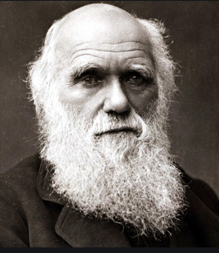
Charles Darwin (1809-1882) introduced the theory of evolution. He was a famous English naturalist (an expert in studying nature), biologist (an expert in living things) and geologist (an expert in rocks and fossils).

Key Vocabulary | Tier 2  - justify: show or prove to be right or reasonable  - investigate: carry out a systematic or formal inquiry to discover and examine the facts so as to establish the truth  - define: make up or establish the character or essence of  - suitable: right or appropriate for a particular person, purpose, or situation  - label: a classifying phrase or name  - environment: the surroundings or conditions in which a person, animal, or plant lives or operates  - adaptation: the process of change by which an organism or species becomes better suited to its environment  - examine: inspect thoroughly in order to determine their nature or condition  - compare: estimate, measure, or note the similarity or dissimilarity between  - categorise: place in a particular class or group  - contrast: the state of being strikingly different from something else  - contributes: help to cause or bring about  - predict: to estimate that a specified thing will happen  - conclude: arrive at a judgement or opinion by reasoning  - describe: give a detailed account of concepts | Tier 3  - evolution: the process by which different kinds of living organism are believed to have developed from earlier forms during the history of the earth  - inherit/inheritance: derive (a quality, characteristic, or predisposition) genetically from one's parents or ancestors  - suited: right or appropriate for a particular person, purpose, or situation  - offspring: a person's child or children  - reproduction: the production of offspring by a sexual or asexual process  - characteristics: a feature or quality belonging typically to a person, place, or thing and serving to identify them  - vary/variation: differ in size, amount, degree, or nature from something else of the same general class  - natural selection: the process whereby organisms better adapted to their environment tend to survive and produce more offspring  - adaptive traits: an aspect of the developmental pattern which facilitates the survival and/or reproduction of its carrier in a certain succession of environments  - inherited traits: refers to a trait or variants encoded in DNA and passed from parent to offspring during reproduction
Post Learning | KS3: genetics and evolution

