Crofton Junior School
History Knowledge Organiser – The Vikings (Year 5)

Unit of Work | The Vikings: Sailors, Traders, Raiders and Beliefs
Text Driver the Unit of Work Links to | Beowulf; The Highwayman
Key Strand | Invasion & Settlement  Beliefs & Culture
Timeline | 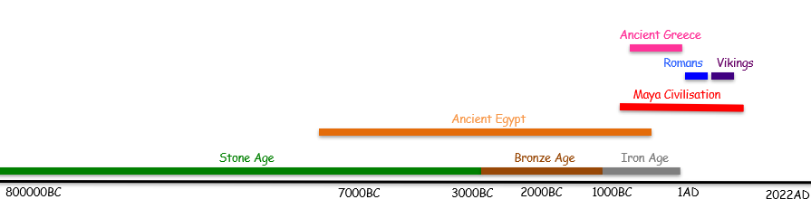
Overview of the Unit of Work | Pupils will learn about the Viking period from the initial attack at Lindisfarne (England) through to Alfred the Great’s peace treaty to allow them to live alongside the Anglo-Saxons. They will explore the design of the Viking long ships and the success of this in relation to their use for invasion and later their settlement. Eventually, the Vikings began to colonise the United Kingdom and settle, bringing their cultures and beliefs and changing the colonised societies forever. Pupils will make links between the Vikings, Romans and the Ancient Egyptians in relation to their invasion strategies and beliefs.
Prior Learning | Invasion & Settlement – Draw upon the children’s knowledge of the settlement of the Ancient Egyptians (Year 4) next to the River Nile and their understanding of the initial failed invasion of England by the Romans (Year 3) due to the ship design.  Beliefs & Cultures – Draw upon the children’s knowledge of the Ancient Egyptians Gods and their beliefs in the afterlife (Year 4).
Sticky Knowledge | Invasion and Settlement  The children will learn:  - When the Viking period took place in relation to other periods of history studied at Crofton Junior School.  - When the Vikings first invaded Britain, the routes they travelled from their homelands and the attack on the holy monastery of Lindesfarne.  - The reasons why monasteries were prime targets for Viking raids and how this supported their success.  - How to be historians by studying the invasion at Lindesfarne and the reliability of the evidence describing the events.  - The significance of Viking longships as an essential part of the Vikings’ ability to travel and explore new lands  - The original design of the longships and how this made them perfect for raiding (linked to the unsuccessful first Roman invasion by Julius Caesar due to the design of the ships: Year 3).  - That Vikings were strategic invaders and why they used rivers and coastlines to invade and later settle (linked to the similar approach of the Ancient Egyptians settlement alongside the River Nile: Year 4).  - Alfred the Great (Anglo-Saxon) made a treaty with the Vikings called Danelaw, paying them in return for peace which was known as Danegeld. To be taught after the Beliefs and Cultures knowledge.  Beliefs and Cultures  The children will learn:  - That the Viking expeditions were not all simply raids, and over time the Vikings began to colonise the places they sailed to.  - They brought their language and customs from their homelands and changed the culture of the colonised societies forever.  - Vikings were Pagans and worshipped many different gods which is similar to the Ancient Egyptians beliefs (Year 4). Each god had different human strengths and weaknesses.  - The differences between the beliefs in the afterlife for the Vikings and the Ancient Egyptians (Year 4).
End of Unit Outcome | By the end of the unit of work, the children will apply their knowledge of the great period of change from when the Vikings initially invaded Britain through to their settlement here. Children will produce a piece of work that highlights the key events they have studied in chronological order.
Key Vocabulary | Tier 2:  Evidence: proof, information showing whether something is true  Compare:  Contrast:  Tier 3:  Scandinavia: Norway, Sweden and Denmark  Explorers: people who travel to a new place to discover what is there  Colonised: settled in a place  Raid: enter a place to steal something  Navigation: finding a way around  Expedition: a journey undertaken by a group of people with a particular purpose  Longships: a long, narrow warship, powered by both oar and sail with many rowers, used by the Vikings and other ancient northern European peoples.  Invasion: an instance of invading a country or region with an armed force  Settlement: a place, typically one which has previously been uninhabited, where people establish a community.  conquer: take control (of a place) by force.  Anglo-Saxons: inhabitants of England before the Vikings  Danegeld: taxes collected for national defence by the Norman kings until 1162.  Norsemen: name for people from Scandinavia (in medieval times)
Post Learning | Beliefs & Cultures – Year 6 Ancient Greeks– The children will draw upon their knowledge of Beowulf studied to compare the main themes of myths and legends in the Viking period to Ancient Greece.  Invasion & Settlement –Year 6 Anglo-Saxons - The children will draw upon their knowledge of the Vikings’ invasion and settlement of Britain in order to make a direct comparison with how the Anglo-Saxons invaded and settled.

