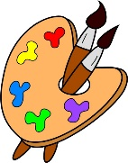
Crofton Junior School – Art Knowledge Organiser – Year 3 – The Hodgeheg - Autumn Term

Unit of Work | Art – Printing a hedgehog in the style of Kandinsky
Text Driver the Unit of Work Links to | The Hodgeheg
Key Strand | Inspiration from the greats  Master Techniques – Print
Overview of the Unit of Work | Pupils will learn about the artistic style ‘Abstract Art’ – specifically Kandinsky’s work. Pupils will learn that Abstract Art is a modern form of art where the picture or sculpture produced does not represent images of our everyday world. Also, they will learn that Kandinsky was one of the pioneers of Abstract Art as he developed his ability to express his feelings and music through shapes and colours in his paintings. Additionally, pupils will learn about the female, African American abstract artist Alma Woodsey Thomas and how her work compares to Kandinsky. Pupils will replicate the techniques that Kandinsky used, use layers of two or more colours, repeat patterns and make their own printing blocks.
Prior Learning | (Taken from the NC)  In KS1, pupils will have used a range of materials creatively to design and make products, used drawing, painting and sculpture to develop and share their ideas, experiences and imagination. They will also have developed a wide range of art and design techniques in using colour, pattern, texture, line, shape, form and space as well learning about the work of a range of artists, craft makers and designers. They will have described the differences and similarities between different practices and disciplines, and making links to their own work.  Vocabulary: repeat, overlap, press, rub, roll, stamp
Sticky Knowledge | Pupils will learn:  - How to make a repeated pattern and how to capture emotions through colour.  - That Abstract Art became popular in the USA during the 20th century, although artists across the world became well known for developing this style.  - Famous artists known for creating Abstract Art include: Wassily Kandinsky, Henry Moore and Jackson Pollock.  - Kandinsky was born in Russia, and as a child enjoyed music including learning to play the cello and piano. He didn’t study art until he was in his thirties.  - Kandinsky was inspired by colours and painters such as Monet. After starting with landscape paintings, he decided to concentrate solely on shapes and colours without the need for a particular subject or topic.  - Alma Woodsey Thomas was a female, African American abstract artist who focussed on accidental beauty.  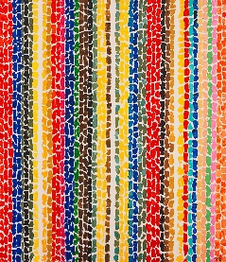  - Replicate the techniques and styles of Kandinsky through printmaking as well as layering colours, repeating patterns, making their own printing blocks with polystyrene and being as precise as they can.  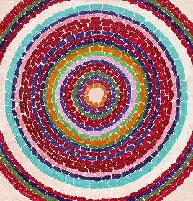  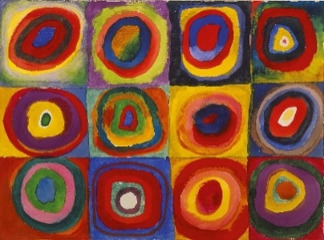  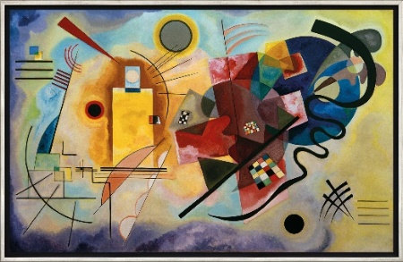  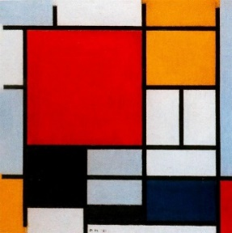  Kandinsky Thomas
Vocabulary | Tier 2  random: not following a plan or pattern  outline: the edge of an object or shape  contrast: big differences between two or more things  layers: a sheet, quantity, or thickness of material, typically one of several, covering a surface  replicate: to copy as exactly as you can  precise: to do something exactly  trend: a fashion or something many people copy  coiled: to shape something in a coil  Tier 3  geometric: consisting of regular shapes  chromatic: having colours  pioneer: one of the first people to do something  spectrum: a range of colours
End of Unit Outcome | The outcome will be to create a repeated printed image of a hedgehog.
Post Learning | During the Spring Term of year 6, pupils will continue the technique of printing with Japanese art, looking closely at Katsushika Hokusai’s work. They will use lino printing as their medium.

