Crofton Junior School – Curriculum Knowledge Organiser
Unit of Work | Science – Chemistry – Year 5
Key Strand | Understand materials – Properties and changes of materials
Overview of the Unit of Work | This concept involves becoming familiar with range of materials, their properties, uses and how they may be altered or changed.
Prior Learning & Vocabulary | Year 1 Materials: objects, fabrics, materials: wood, plastic, glass, metal, water, rock, brick, paper, elastic, foil, card, rubber wool, clay, hard, soft. Properties: stretchy, stiff, bendy, waterproof, absorbent, breaks/tears, rough, smooth, shiny, dull  Year 2 Materials: transparent, opaque, reflective, translucent, non-reflective, suitable/unsuitable, rigid, flexible, strong/weak, shape, changed, push, pull, twist, squash, bend, pinch, roll, squeeze  Year 3 Materials: rock, stone, pebble, boulder, soil (sandy/clay/chalky), fossils, grains, crystals, hard/soft, texture, absorb water, permeable, impermeable, marble, chalk, granite, sandstone, slate, peat, igneous, sedimentary, metamorphic, fossilisation, sediment  Year 5 Materials: states of matter, solid, liquid, gas, air, oxygen, powder, grain/granular, change state, ice/water/steam, water vapour, heated, cooled, temperature, degrees Celsius ºC, melt, freeze, solidify, melting point, molten, boil/boiling point, evaporate/evaporation, condense/condensation, water cycle, precipitation, transpiration
Sticky Knowledge | 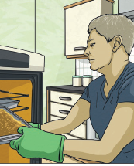  Different materials are used for particular jobs based on their properties: electrical conductivity, flexibility, harness, insulators, magnetism, solubility, thermal conductivity and transparency.  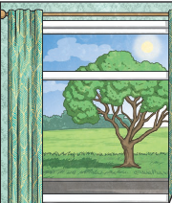  For example, glass is used for windows because it is hard and transparent. Oven gloves are made from thermal insulator to keep the heat from burning your hand.
 | 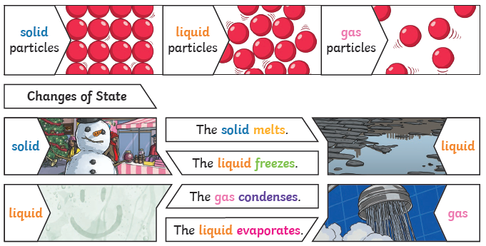 | Reversible changes, such as mixing and dissolving solids and liquids together, can be reversed by…  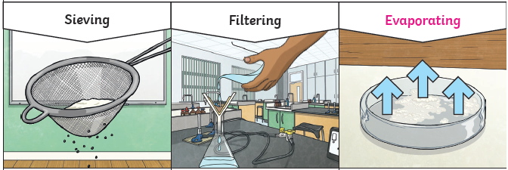
 | Dissolving  A solution is made when solid particles are mixed with liquid particles. Materials that will dissolve are known as soluble. Materials that won’t dissolve are known as insoluble. A suspension is when the particles don’t dissolve.  Examples: Sugar is a soluble material. Sand is an insoluble material. | Smaller materials are able to fall through the holes in the sieve, separating them from larger particles. | The solid particles will be caught in the filter paper by the liquid will be able to get through. | The liquid changes into a gas, leaving behind the solid.
 | Irreversible changes often result in new product being made from the old materials (reactants). For example, burning wood produces ash.
New Vocabulary | solubility, electrical conductivity, thermal conductivity, dissolve, solution, soluble, insoluble, solute, solvent, particle, mix/mixture, filtering, sieving, residue, reversible changes, new material, reversible, irreversible
Post Learning | KS3: The nature of matter

