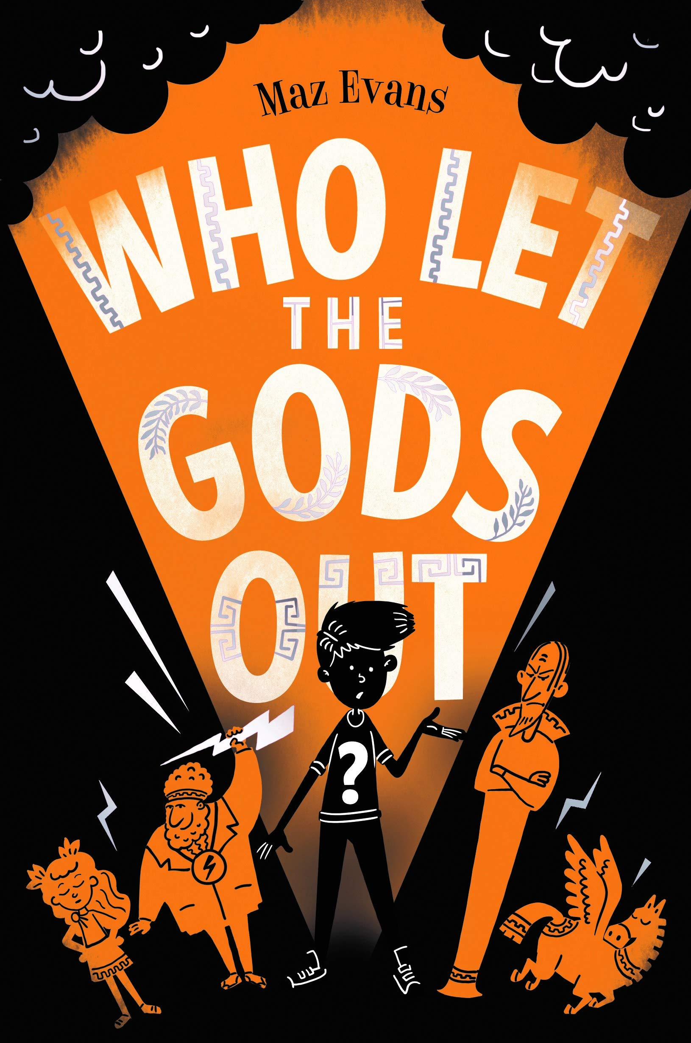
Purpose, Audience and Register
Purpose = The purpose is to recall what has happened to Elliot Hooper from a first-person perspective to allow him to organise and articulate his thoughts and feelings after his initial encounter with Virgo.
Audience = Since it is a diary, the audience is Elliot, the writer. It is a personal recount for personal use.
Levels of Formality = An informal register will be used since it is written from the perspective of an 11-year-old boy for personal use only.
Crofton Junior School
English Knowledge Organiser Year 6 = Autumn 1 (Unit 1)
Unit of Work | Diary entry from the perspective of Elliot Hooper
Text Type / Genre | Non-fiction - Diary Entry (Recount)
Text Driver the Unit of Work links to | Who Let The Gods Out? By Maz Evans

Overview of the Unit of Work including End of Unit Outcome | Pupils will recall their grammatical knowledge of phrases and clauses from Year 5 including relative clauses, the use of parenthesis and expanded noun phrases through application tasks relating to the text driver: Who Let the Gods Out? by Maz Evans. They will study Chapter 5, in depth, with a particular focus on the initial meeting of the main characters, Elliot and Virgo. After exploring the thoughts, feelings, actions and motives of these characters during the chapter, pupils will immerse themselves in the role of Elliot Hooper. They will plan and draft an informal diary entry expressing his initial impressions of Virgo in Chapter 5. Pupils will reflect upon their initial draft and make purposeful edits to up level this further with a particular focus on capturing the character of Elliot skilfully and accurately. Pupils will recall their knowledge of proof reading to proof read their finalised draft for spelling, punctuation and grammatical errors.
Links to Reading Objectives | Pupils will explore the characters of Elliot and Virgo within Chapter 5 of Who Let The Gods Out? They will focus on their initial impressions of Virgo, who is first introduced in this chapter, by analysing Elliot’s thoughts, feelings and actions. They will explore how the author, Maz Evans, expresses the personality of Elliot within this chapter and they will use this information to predict how both characters will respond and act to an encounter with one another. This prediction will be integrated within the diary entry.
Prior Learning | Vocabulary, Grammar and Punctuation Knowledge:  - In Year 5, pupils used expanded noun phrases to convey information. They used relative clauses beginning with who, which, where, when, whose, that or with an omitted relative pronoun. Furthermore, pupils used brackets, dashes or commas to indicate parenthesis.  Text Type – Diary:  - In Year 5, pupils wrote a diary entry in the autumn term to recount Charlie Bucket’s first encounter with the chocolate factory including his initial impressions of Mr Wonka. This was inspired by the text: Charlie and the Chocolate Factory.  - In Year 4, pupils wrote a diary entry in the autumn term to recount Rosie’s day when Great Aunt Rose came to stay and the making of the cheese-copter. This was inspired by the text: Rosie Revere Engineer.  - In Year 3, pupils wrote a diary entry in the spring term to express Mary Anning’s thoughts and feelings when she first discovered the Ichthyosaur. This was inspired by the text: Stone Girl, Bone Girl – The Story of Mary Anning of Lyme Regis.
Text Type Features  (Diary) | - A diary is a personal recount so it must be written in the first person and it must use the past tense to retell events in chronological order.  - It must include an introduction, the date and/or time and personal emotions and feelings to show the writer’s point of view.  - Diaries should be written in paragraphs to organise the main ideas. An introduction should answer some of the 5 Ws (when, what, who, where and why) and a conclusion should summarise the writer’s feelings.  - Diaries are written in an informal style and must use age-appropriate language choices and conventions to reflect the person whose perspective is being expressed in the diary.
Sticky Knowledge | During the autumn term, time is spent revisiting key sticky knowledge from previous year groups to ensure this is secure before building on this.  The children will learn:  - A relative clause is a type of subordinate clause that adds extra information to a main clause. They are usually (but not always) introduced with a relative pronoun: that, which, who, whose, where and when. (Year 5 revision)  - A relative clause can be restrictive (essential) or non-restrictive (non-essential). If it is restrictive, it cannot be left out of the sentence without changing the meaning – it is essential to the sentence. A non-restrictive relative clause adds extra information about the noun which could be left out and the sentence would still make sense. This extra information is separated from the main clause by a pair of commas, brackets or dashes. (Year 5 revision)  - Parenthesis is a word or group of words inserted into a sentence to provide additional, often non-essential, information which could be removed without affecting the sense of the sentence. It is punctuated with a pair of brackets, dashes or commas. (Year 5 revision)
New Vocabulary | Perspective – a point of view  Repossessed – retake possession of  Unscathed – without suffering any injury or harm  Debris – scattered pieces of rubbish or remains  Dilapidated – a building that is run down and beyond repair  Coaxing – gently persuading  Relative clause – a type of subordinate clause (often starting with a relative pronoun) that adds extra information to a main clause  Parenthesis – a word or group of words inserted into a sentence to provide additional, often non-essential information  Omitted – leave out or exclude  Restrictive - essential  Non-restrictive – non-essential
Post Learning | - In Year 6, pupils will recall their knowledge of recounts and extend this further to write a newspaper article in the autumn term to retell the significant events that took place at Buckingham Palace when Hypnos visited the Queen of England. This will be inspired by the text: Who Let the Gods Out?  - In Year 6, pupils will use their knowledge of writing in the first person in the summer term to write a first-person narrative from the perspective of Michael to describe the island from his perspective when he first wakes up on the beach following his ordeal at sea. This will be inspired by the text: Kensuke’s Kingdom.

