 | Text Driver | Autumn  Units of Work (text types) | Text Driver | Spring  Units of Work (text types) | Text Driver |  | Summer  Units of Work (text types)
Summary of Progression
In Year 3, picture books and shorter novels are used to immerse children into stories, begin their love of reading at Crofton Junior School and establish the foundation of understanding texts. The stories chosen stimulate writing in an increasing range of text types as children move through the year. In autumn term, there is a focus on revising and recapping prior learning from Key Stage 1, and over the course of the year, vocabulary and grammatical structures, such as introducing dialogue and paragraphing, are focused upon (see Writing skills progression document for these specific areas).
Crofton Junior School - Year 3 | 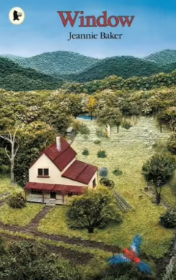  Window  Author = Jeannie Baker  Picture Book  The Hodgeheg  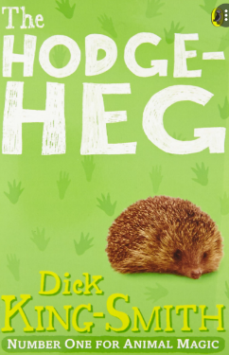  Author = Dick King-Smith  Modern Fiction | Unit of Work: Poetry  Performance Poetry  Purpose: Entertain  The purpose is to create a Sound Collector poem inspired by the sounds collected from around the school building in order to entertain an audience. | Stone Girl, Bone Girl: The Story of Mary Anning of Lyme Regis  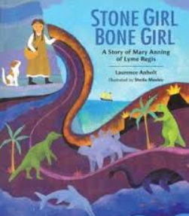  Author = Laurence Anholt  Science – fiction  Stone Age Boy  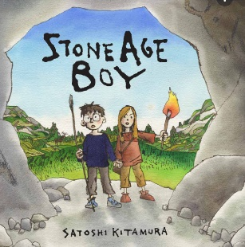  Author = Satoshi Kitamura  Fiction with historical setting | Unit of Work: Biography  Non-fiction (Biographical writing)  Purpose: Recount events and Entertain  The purpose is to reflect upon research to present the facts about Mary Anning’s life in chronological order (from birth to death) including how she made a difference in the world. The aim is to entertain people who are interested in her and her achievements. | Escape from Pompeii  Author = Christina Balit  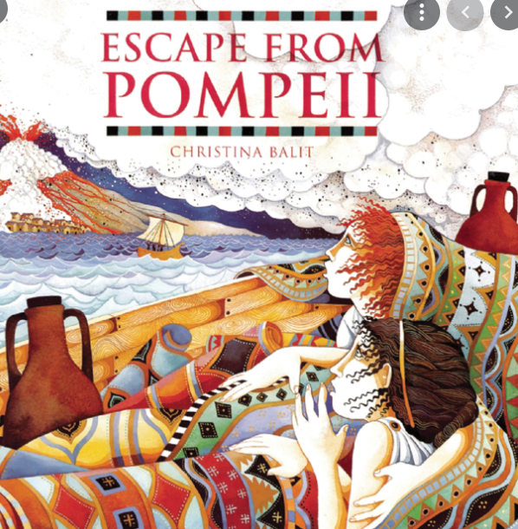  Fiction with historical setting / Adventure  The Firework Maker’s Daughter  Author = Philip Pullman  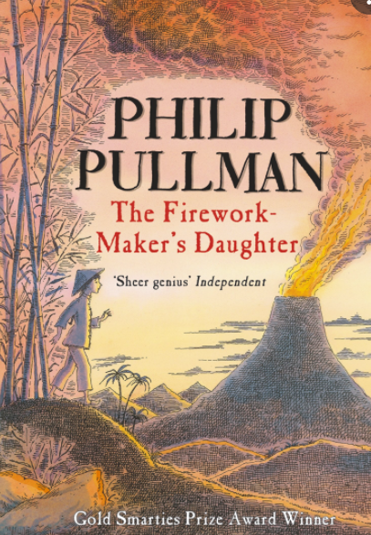  Fiction – Adventure | Unit of Work: Narrative  Fiction  Purpose: Entertain  The purpose is to retell the whole text with different main characters to entertain and engage the audience.
 |  | Unit of Work: Setting Description  Fiction  Purpose: Entertain  The purpose is to describe the setting through the window of Sam’s house as an adult to engage and entertain the audience and create a clear image in their minds. |  | Unit of Work: Diary Entry  Non-fiction (Autobiographical writing)  Purpose: Recount events and Entertain  The purpose is to recount Mary Anning’s discovery of the Ichthyosaur from a first-person perspective. The aim is to allow her to organise and articulate her thoughts and feelings after this event. |  | Unit of Work: Explanation Text  Non-fiction  Purpose: Inform and Explain  The purpose is to explain how a volcano is formed in order to help the reader to fully understand this process.
 |  | Unit of Work: Missing Poster  (Character Description)  Fiction  Purpose: Inform  The purpose is to create a missing poster for Max to inform members of the public about his disappearance by describing his appearance so that they can help to find him and return him home. |  | Unit of Work: Character Description from a first-person perspective  Fiction  Purpose: Entertain  The purpose is to describe the character of Om (a Stone-Age child) from the first-person perspective of a 21st century child so that their thoughts and feelings can be expressed. |  | Unit of Work: Narrative from a first-person perspective  Fiction  Purpose: Entertain  The purpose is to retell a significant event from the perspective of Lila to entertain and engage the audience and to express her personal thoughts and feelings.
 |  | Unit of Work: Instructions  (How to cross the road safely)  Non-fiction  Purpose: Inform and Educate  The purpose is to inform and educate hedgehogs about how to cross the road appropriately to ensure they remain safe at all times. |  | Unit of Work: Information Text  Non-fiction (Non-chronological report)  Purpose: Inform  The purpose is to provide detailed information about Skara Brae in order to help the reader to fully understand this historical site and what it has taught us about Stone Age Britain. |  | Unit of Work: Volcano Shape Poem  Performance Poetry  Purpose: Entertain  The purpose is to create a shape poem inspired by volcanoes to entertain and engage an audience when performed.

