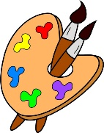
Crofton Junior School – Art Knowledge Organiser – Heroes and Villains – Year 5 Summer Term

Unit of Work | Art – Heroes and Villains – Sketching Grendel
Text Driver the Unit of Work Links to | Beowulf
Key Strand | Develop Ideas  Master Techniques – Drawing
Overview of the Unit of Work | Pupils will learn about the artistic style ‘Expressionism’ and how it relates to real images being distorted and exaggerated in order to express the inner feelings or ideas of an artist. They will also learn that the art is often emotional and even mystical, with frequent use of shocking and vivid colours.  Pupils will collect information, sketches, resources, and present ideas imaginatively in a sketchbook and comment on the sculptures with a fluent grasp of visual language. Additionally, they will use a variety of techniques to add interesting effects which may also show movement and shadows.
Prior Learning & Vocabulary | During the Autumn and Spring Term in year 3 and Spring and Summer Term of year 4, the children will have learnt to use a sketchbook to sketch ideas imaginatively. Also, during the Summer Term of year 3, the children will have developed their drawing techniques by sketching Mount Vesuvius erupting.  Vocabulary: sketch, refine, variety, hard, soft, pressure, thickness, texture, tone
Sticky Knowledge | Pupils will learn:  - That Expressionism in art relates to how real images are distorted and exaggerated in order to express inner feelings or ideas. This will be compared to Realism.  - For Expressionists, colour did not have to be realistic but had more of a symbolic value which was often determined by the artist themselves. Colour might be used to express pleasure and wellbeing or to show terror and despair.  - The impressionistic style was create through the use if instinct and no prior planning. This ensured that the artist worked purely in the moment with no use of intellect. To paint like an Expressionist, it is best to limit the range of colours and use them straight from the tube without mixing.  - Expressionists techniques used for sculpture are particularly focused on exaggeration. Rather than sculpting the full physical form of the subject, sculptors emphasise prominent features by distorting or elongating them, making it less realistic.  - How to use different sketching techniques with pencil and coloured pencil to add interesting techniques (e.g. shadows, direction of sunlight).  - How to use colour, lines, hardness and softness to represent movement and emotion.  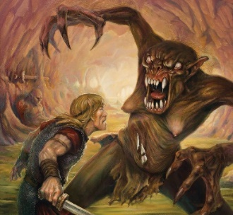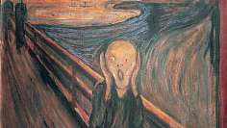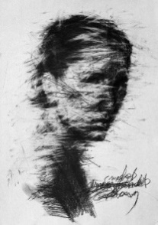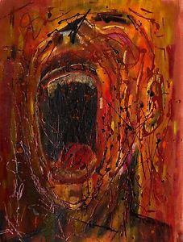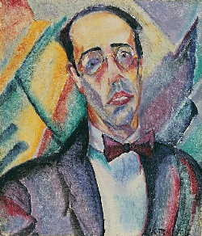  Edvard Munch Anita Malfatti
End of Unit Outcome | By the end of this unit of work, the children will use their sketching skills to sketch an image of what they think Grendel (from Beowulf) looks like.
New Vocabulary | Tier 2  shadows: a dark area or shape produced by something obstructing light  direction: a course along which someone or something moves  mystical: not obvious to human intelligence or senses  instinct: a feeling that something is right  emphasise: make (something) more clearly defined  Tier 3  impressionism: a style in painting originating in France in the 1860s, focussing on the visual impression of the moment, especially in terms of the shifting effect of light and colour  prominent: very noticeable  elongating: stretching, making longer
Post Learning | During the Spring Term of year 6, pupils will use a sketchbook to sketch ideas imaginatively.

