Crofton Junior School – Curriculum Knowledge Organiser
Unit of Work | Science – Biology – Year 5
Key Strand | Investigate living things (and their habitats)
Overview of the Unit of Work | This concept involves becoming familiar with a wider range of living things, including insects and understanding life processes.
Prior Learning & Vocabulary | Year 2 (living things): living, dead, move, grow, feed, offspring, habitats (pond, woodland, meadow, ocean, forest, seashore), micro-habitat, damp/wet/dry, dark/light, hot/warm/cold/cool, suited/suitable, basic needs, depend, food, shelter  Year 4 (living things): classification keys, environment, insect, fish, amphibians, reptiles, birds, mammals, vertebrates, invertebrates, human impact,
Sticky Knowledge | Some living things such as plants, contain both male and female sex cells. In others, such as humans, they contain either the male or female sex cells. Mammals use sexual reproduction to produce their offspring. The male sex cell, called the sperm, fertilises the female sex cells. After the fertilised cell divides into different cells it will form a baby with a beating heart. Finally, the baby will grow inside the female until the end of the gestation period when the baby is born.  Exceptions are echidnas and platypus that are mammals but they lay eggs rather than giving birth to live young.  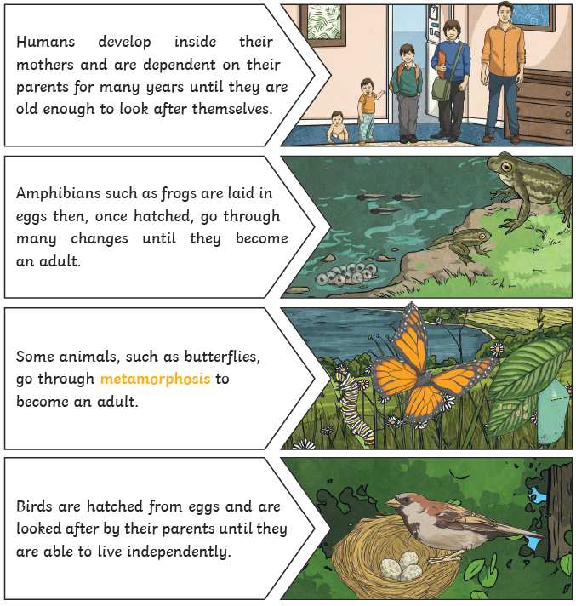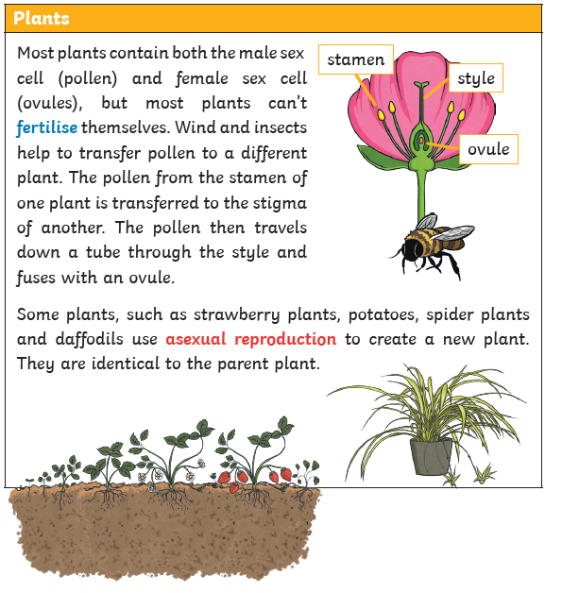
Key Vocabulary | Tier 2  - compare: estimate, measure, or note the similarity or dissimilarity between  - contrast: the state of being strikingly different from something else  - describe: give a detailed account of concepts  - identify: establish or indicate who or what (someone or something) is  - demonstrate: give a practical exhibition and explanation  - recognise: identify from knowledge of appearance or character  - categorise: place in a particular class or group  - classify: arrange in classes or categories according to shared qualities or characteristics  - propose: put forward (a plan or suggestion) for consideration by others  - environment: the surroundings or conditions in which a person, animal, or plant lives or operates  - impact: the action of one object coming forcibly into contact with another  - conclude: arrive at a judgement or opinion by reasoning  - summarise: give a brief statement of the main concepts  - recognise: identify from knowledge of appearance or character  - source: a place, person, or thing from which something originates or can be obtained | Tier 3  - life cycle: the series of changes in the life of an organism including reproduction  - reproduction: the production of offspring by a sexual or asexual process  - sexual reproduction: the production of new living organisms by combining genetic information from two individuals of different types (sexes)  - asexual reproduction: is a type of reproduction that does not involve the fusion of gametes or change in the number of chromosomes  - germination: the development of a plant from a seed or spore after a period of dormancy  - pollination: the transfer of pollen to a stigma, ovule, flower, or plant to allow fertilization  - seed formation: a seed is formed when fertilised ovule divides by mitosis  - seed dispersal: the mechanism by which plant seeds are transported to new sites for germination and the establishment of new individuals  - pollen: a fine powdery substance, typically yellow, consisting of microscopic grains discharged from the male part of a flower or from a male cone  - stamen: the male fertilizing organ of a flower, typically consisting of a pollen-containing anther and a filament  - stigma: a mark of disgrace associated with a particular circumstance, quality, or person  - plantlets (E.g. spider plant): a small or young plant  - runners (e.g. strawberry plant): a slender stem that grows horizontally along the ground  - eggs: the female sex cell  - live young: mammals give birth to live offspring  - gestation: the process or period of developing inside the womb between conception and birth  - metamorphosis: the process of transformation from an immature form to an adult form in two or more distinct stages
Post Learning | Year 6: Living things

