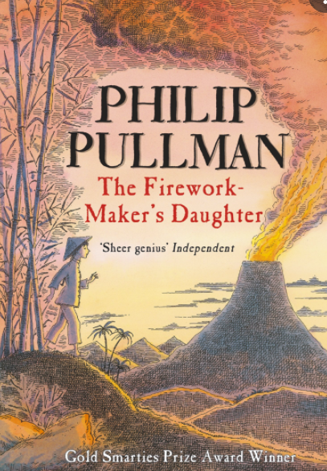
Purpose, Audience and Register
Purpose = The purpose is to retell a significant event from the perspective of Lila to entertain and engage the audience and to express her personal thoughts and feelings.
Audience = The audience are children aged 7-11, who have been reading the story (The Firework Maker’s Daughter) or children interested in fantasies.
Levels of Formality = An informal register is used as it is written in the first person from the perspective of a young girl on a quest.
Crofton Junior School
English Knowledge Organiser Year 3 Summer Unit 3
Unit of Work | Narrative from a first-person perspective
Text Type / Genre | Narrative
Text Driver the Unit of Work links to | The Firework Maker’s Daughter by Philip Pullman

Overview of the Unit of Work including End of Unit Outcome | Children will read and explore the text The Firework Maker’s Daughter in depth. Children will immerse themselves in Lila’s mysterious quest for the Royal Sulphur by thinking about personality and punctuation to read aloud and perform sections of chapter 4, showing understanding through intonation, tone, volume and action. They will understand how the author, Philip Pullman, uses figurative language techniques such as onomatopoeia and similes to describe characters in the text. Children will demonstrate their understanding by retrieving and recording information within comprehension tasks. Furthermore, pupils will create freeze frames to capture the moment when Lila first encountered the pirates. Children will recap their knowledge of subordinate clauses through an application task linked to the text driver where they will focus on the accurate use of a range of subordinate conjunctions and the precise manipulation of subordinate clauses within sentences. Children will then recall their knowledge from Year 2 to explore the use of apostrophes for singular possession and contractions, which they will apply to an application task. They will also build upon their knowledge of direct speech by using inverted commas to punctuate when a character is speaking. Children will plan and write a narrative from the perspective of Lila when she found The Grotto of the Fire-Fiend. They will use expanded noun phrases and similes to describe the ghosts, Hamlet, the Fire Spirits and Razvani. They will include a range of writing skills taught in the autumn and spring terms: subordinate clauses, prepositions, inverted commas and adverbs. Pupils will reflect upon their initial draft and begin to make meaningful edits to up level this further with a particular focus on the purposeful use of language. They will ensure grammatical techniques are used effectively to leave an impression on the reader. Finally, children will recall their knowledge of proof reading to proof read their finalised draft for spelling, punctuation and grammatical errors.
Links to Reading Objectives | Pupils will begin to explore the text driver – The Firework Makers Daughter. Before reading this, they will initially explore the front cover, blurb and illustrations and look at items (sulphur and a white elephant) from the story to predict who could own them and what they might be used for. Pupils will reflect upon their predictions and what they would like to know once they have read the whole text. Whilst they are reading, children will discuss the understanding and meaning of words in context by visualising the character, Rambashi. Additionally, they will understand how the author, Philip Pullman, uses figurative language techniques such as onomatopoeia and similes to describe characters in the text. Children will demonstrate their understanding by retrieving and recording information within comprehension tasks. Furthermore, pupils will create freeze frames to capture the moment when Lila first encountered the pirates. In addition, children will think about personality and punctuation to read aloud and perform sections of chapter 4, showing understanding through intonation, tone, volume and action. Children will also be detectives and read between the lines to infer what the author means using evidence from the text.
Prior Learning | Vocabulary, Grammar and Punctuation Knowledge:  - In Year 3 in the autumn term, pupils recalled that a subordinating conjunction introduces a subordinate clause (a clause that does not make sense on its own). Subordinating conjunctions (when if, that and because) join a main clause and a subordinate clause together. (Year 2 revision)  - A preposition is a type of word used to express time, place or cause. Prepositions tell you when, where or why things happen. Examples of prepositions include words like after, before, on, under, inside and outside. (Year 3 Spring Unit 1 revision)  - Inverted commas are used to punctuate direct speech. (Year 3 Summer Unit 1 revision)  Text Type – Narrative  - In Year 3, pupils have drafted a range of narratives in the autumn and spring terms including in the form of a diary, setting description and character description from a first-person perspective.  - In Year 3 in the summer term, pupils wrote a narrative to retell the text ‘Escape from Pompeii’ from the perspective of a different character.
Text Type Features  (Narrative) | - A narrative will create a picture in the reader’s mind through powerful description, introduce any characters and create the atmosphere for the story.  - A description must use powerful and effective expanded noun phrases in order to create the required atmosphere. It must include references to the five senses (touch, smell, sight, sound and taste) and descriptions will use ambitious vocabulary.
Sticky Knowledge | During the summer term, time is spent revisiting key sticky knowledge from the autumn and spring terms to embed this knowledge.  The children will learn:  - A simile is a comparison between two different things, using the words ‘as’ or ‘like’.  - Similes encourage the reader to use their imagination and encourage them to paint a picture in their mind. A simile is a figurative language technique.  - How to use apostrophes to mark where letters are missing in spelling and to mark singular possession in nouns [for example, the girl’s name] (Year 2 revision).  - Recap - Inverted commas are use to punctuate direct speech. Direct speech is a sentence where the exact words that are spoken are written in inverted commas. Direct speech can be used in multiple written texts. It is widely used in fiction where it can help readers to understand characters better.
New Vocabulary | Cavern - a large cave  Barren - bleak and lifeless  Sulphur – It was known in ancient times as brimstone, or “burning stone,” because it burns very easily. Prehistoric humans used sulfur to make cave paintings.  Courtier - a person who attends a royal court as a companion or adviser to the king or queen  Pungent – a strong, sharp taste or smell  Pestilential – annoying or irritating  Tarpaulin - a tarpaulin or tarp is a large sheet of strong, flexible, water-resistant or waterproof material  Stoutest – a strong built person  Plume - A plume is a special type of bird feather. They often have a decorative purpose and they are commonly used among marching bands, worn on a hat or helmet.  Gourd - typically large fruit with a hard skin  Perish – to disappear or die suddenly
Post Learning | - In Y4 in the autumn term, pupils will write a first-person narrative to describe Scrooge’s first encounter with the Ghost of Christmas Past. This will be inspired by the text: A Christmas Carol.  - In Y4 in the spring term, pupils will write their own ending when Ali returns to the village following the discovery of Tutankhamun’s tomb. This will be inspired by the text: I was there… Tutankhamun’s tomb.  - In Y4 in the summer term, pupils will write the next chapter based on Ruby encountering the leopard in chapter 24 of the following text: When the Mountains Roared.  - In Y5 in the spring term, pupils will write a narrative to rewrite an event in the story from the perspective of the main character. This will be inspired by the text: The Explorer.  - In Y5 in the summer term, pupils will write a narrative to describe the duel between Grendel and Beowulf. This will be inspired by the text: Beowulf.  - In the spring term of Y6, pupils will write a narrative detailing the ‘Dark Deed’ where King Duncan is murdered by his cousin. This will be inspired by the text: Macbeth.  - In the summer term of Y6, pupils will write a first-person narrative from the perspective of Michael to describe the island from his viewpoint when he first wakes up on the beach following his ordeal at sea. This will be inspired by the text: Kensuke’s Kingdom.

