Crofton Junior School – Curriculum Knowledge Organiser

Unit of Work | Science – Physics – Year 4
Key Strand | Investigate sound and hearing
Overview of the Unit of Work | This concept involves understanding how sound is produced, how it travels and how it is heard
Prior Learning & Vocabulary | N/A
Sticky Knowledge | 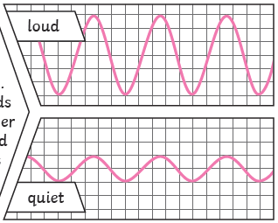  Sound is a type of energy. Sounds are created by vibrations. The louder the sound, the bigger the vibration.  The size of a vibrations is called the amplitude. Louder sounds have a larger amplitude and quieter sounds have a smaller amplitude.  Pitch is a measure of how high or low a sound is. Faster vibrations create a higher pitch and slower vibrations create a lower pitch.  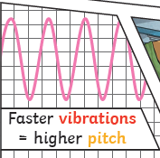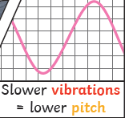  Sound can travel though solids, liquids and gases by vibrating the particles. The reason for is that the vibrating particles are closer together in a solid. Sound cannot be travel in a vacuum.  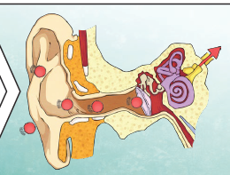  Inside your ear, the vibrations hit the eardrum and are then passed to the middle and then into the inner ear. They are then changed into electrical signals and sent to your brain in order for you to recognise a sound.
Key Vocabulary | Tier 2  - compare: estimate, measure, or note the similarity or dissimilarity between  - contrast: the state of being strikingly different from something else  - similar: having a resemblance in appearance, character, or quantity, without being identical  - describe: give a detailed account of concepts  - predict: to estimate that a specified thing will happen  - propose: put forward (a plan or suggestion) for consideration by others  - relationship: the way in which two or more things are connected, or the state of being connected  - identify: establish or indicate who or what (someone or something) is  - conclude: arrive at a judgement or opinion by reasoning  - source: a place, person, or thing from which something originates or can be obtained | Tier 3  - sound: vibrations that travel through the air or another medium and can be heard  - noise: a sound, especially one that is loud or unpleasant or that causes disturbance  - volume: quantity or power of sound; degree of loudness - loud/quiet  - vibrate/vibration: (of a sound) resonate; continue to be heard  - travel: go or be moved from place to place  - solid/liquid/gas: three times of states of matter which are distinct forms in which matter can exist  - medium: the intervening substance through which sensory impressions are conveyed or physical forces are transmitted  - pitch: the quality of a sound governed by the rate of vibrations producing it; the degree of highness or lowness of a tone - high-low  - tune: melody, especially one that characterizes a particular piece of music  - tuned: adjust (a musical instrument) to the correct or uniform pitch  - fainter: (of a sound) barely perceptible  - muffle: cover or wrap up (a source of sound) to reduce its loudness  - insulation: the action of protect (something) by interposing material that prevents the intrusion of sound  - instrument: an object or device for producing musical sounds  - percussion: musical instruments played by striking with the hand or with a stick or beater, or by shaking, including drums, cymbals, xylophones, gongs, bells, and rattles  - strings: the stringed instruments (including violin, cello, guitar) in an orchestra  - brass: brass wind instruments (including trumpet, horn, and trombone) forming a band or a section of an orchestra  - woodwind: wind instruments other than brass instruments forming a section of an orchestra, including flutes, oboes, clarinets, and bassoons
Post Learning | KS3 – waves

