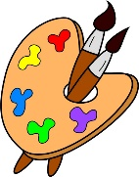
Crofton Junior School – Art Knowledge Organiser – Andy Goldsworthy – Year 5 Spring Term

Unit of Work | Art – Making a wire tree sculpture with a clay base
Text Driver the Unit of Work Links to | The Explorer
Key Strand | Develop Ideas  Master Techniques – Sculpture
Overview of the Unit of Work | Pupils will learn about the artist Andy Goldsworthy and how he uses the natural environment to form his sculptures/artwork. He classes himself as both a sculptor and a photographer as he documents his artworks in situ where he then leaves it to break down or dissolve. Goldsworthy became part of the Environmental Art Movement in the 1980’s and uses nature as his muse, often using the patterns of fossils in his work. Pupils will also look at the work of American artist Kathy Klein and compare her work to Goldsworthy’s. Pupils will collect information, sketches, resources, and present ideas imaginatively in a sketchbook and comment on the sculptures with a fluent grasp of visual language. Additionally, they will create a small wire tree sculpture growing from a clay base. They will adorn the clay with patterns using tools to carve and add shape and texture, creating a piece that combines visual and tactile qualities.
Prior Learning & Vocabulary | During the Spring Term in year 3, the children will have learnt about the great artist Henry Moore and will have used clay to create sculptures in his style.  Vocabulary: combine, recognisable, forms, nets, solids, convey, expression, mouldable, detail, rolling, cutting, carving, moulding
Sticky Knowledge | Pupils will learn:  - How Andy Goldsworthy creates sculptures/artworks in nature using natural materials  - How Goldsworthy leaves his work where he made them in the landscape for them to be stumbled upon and eventually disappear or dissolve for example ‘Rowan leaves laid around a hole, Yorkshire (1987)’  - How Goldsworthy also considers himself a photographer as well as a sculptor.  - How he became part of the Environmental Art Movement in the 1980s.  - How he uses nature as his muse and often creates patterns in his work inspired by fossils.  - About the work of American artist Kathy Klein and how she creates sculptures using natural materials in response to meditation and her Buddhist beliefs.  - How to collect sketches and present them imaginatively in a sketchbook, commenting on visual language.  - How to manipulate and mould wire to create the sculpture of a tree.  - How to use tools to carve and add shape and texture into clay.  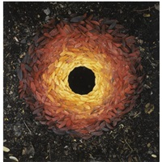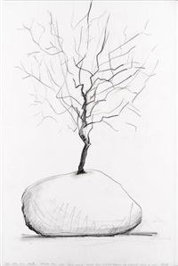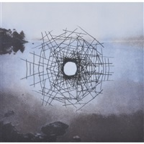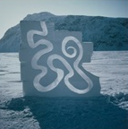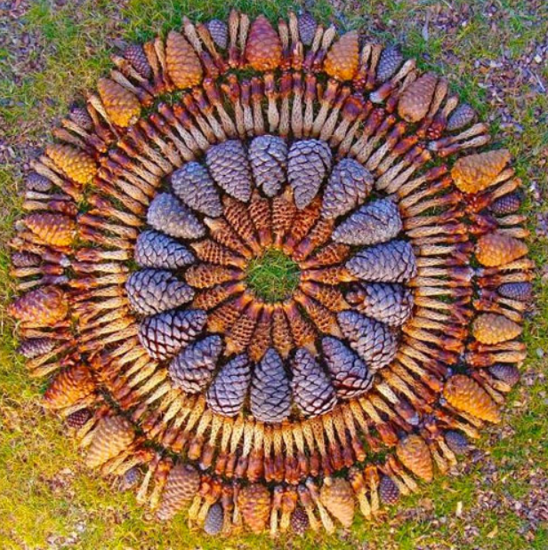
End of Unit Outcome | At the end of this unit of work, the children will make a small sculpture inspired by Andy Goldsworthy using both clay and wire.
New Vocabulary | Tier 2  potential: having or showing the capacity to develop into something in the future.  unexpected: not expected or regarded as likely to happen.  visual: relating to seeing or sight.  tactile: of or connected with the sense of touch.  stability: the state of being stable  qualities: the standard of something as measured against other things of a similar kind  manipulate: handle or control a tool or material in a skilful manner  Tier 3  interpretation: a stylistic representation of a creative work or dramatic role.  framework: an essential supporting structure
Post Learning | During the Autumn Term of year 6, pupils will use sculptural techniques by creating clay pots inspired by Ancient Greece.

