Crofton Junior School – Curriculum Knowledge Organiser
Unit of Work | Science – Physics – Year 5
Key Strand | Understand the Earth’s movement in space
Overview of the Unit of Work | This concept involves understanding what causes seasonal changes, day and night
Prior Learning & Vocabulary | N/A
Sticky Knowledge | 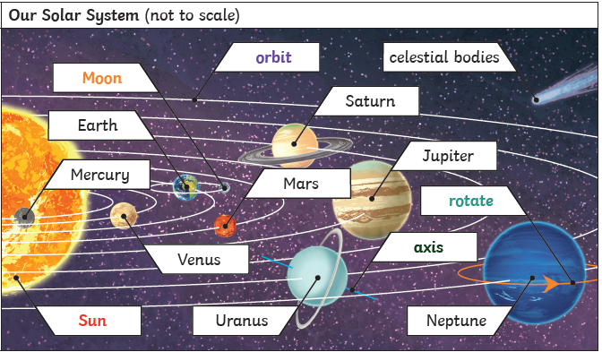  Earth rotates on its axis once every 24hours (a day). At the same time as it rotates, it orbits the sun which takes a little more than 365 days (a year). Daytime occurs when the side of the Earth is facing the Sun; night occurs when the Earth is facing away from the Sun. It appears that the sun rises in the East and sets in the West, but the Sun does not move at all: it is due to the Earth’s rotation. The Moon orbits Earth is an oval-shaped path while spinning on its axis creating the Moon phases.  The order of the planets is Mercury, Venus, Earth, Mars, Jupiter, Saturn, Uranus, Neptune and Pluto (classified as dwarf planet 2006)
Key Vocabulary | Tier 2:  - describe: give a detailed account of concepts  - label: a classifying phrase or name  - evidence: the available body of facts or information indicating whether a belief or proposition is true or valid  - extract: remove or take out, especially by effort or force  - justify: show or prove to be right or reasonable  - relationship: the way in which two or more things are connected, or the state of being connected  - evidence: the available body of facts or information indicating whether a belief or proposition is true or valid  - demonstrate: give a practical exhibition and explanation | - Tier 3:  - Earth: the planet on which we live; the world  - planets: a celestial body moving in an elliptical orbit round a star  - Sun: the star round which the earth orbits  - solar system: the collection of eight planets and their moons in orbit round the sun, together with smaller bodies in the form of asteroids, meteoroids, and comets. The planets of the solar system are (in order of distance from the sun) Mercury, Venus, Earth, Mars, Jupiter, Saturn, Uranus, and Neptune  - moon: the natural satellite of the earth, visible (chiefly at night) by reflected light from the sun  - celestial body: is an aggregation of matter in the universe (such as a planet, star, or nebula) that can be considered as a single unit  - sphere/spherical: a round solid figure, or its surface, with every point on its surface equidistant from its centre  - rotate/rotation: move or cause to move in a circle round an axis or centre  - orbit: the curved path of a celestial object or spacecraft round a star, planet, or moon, especially a periodic elliptical revolution  - revolve: move in a circle on a central axis  - revolution: the movement of an object in a circular or elliptical course around another or about an axis or centre  - geocentric model: any theory of the structure of the solar system (or the universe) in which Earth is assumed to be at the centre of it all  - heliocentric model: a cosmological model in which the Sun is assumed to lie at or near a central point  - shadow clocks: a device indicating the time during the hours of sunlight by means of a stationary arm (the gnomon) that casts a shadow onto a plate or surface marked in hours  - sundial: the earliest type of timekeeping device, which indicates the time of day by the position of the shadow of some object exposed to the sun's rays  - astronomical clocks: a clock with special mechanisms and dials to display the relative positions of the sun, moon, zodiacal constellations, and sometimes major planets.
Post Learning | KS3 – space physics

