Crofton Junior School – Curriculum Knowledge Organiser
Unit of Work | Science – Physics – Year 6
Key Strand | Understanding light and seeing
Overview of the Unit of Work | This concept involves understanding how light and reflection affect sight
Prior Learning & Vocabulary | Year 2 (materials): transparent, opaque, translucent  Year 3 (light): light, light source, names of light sources, dark/darkness, reflect, reflective, mirror, shadow, block, direct/direction,
Sticky Knowledge | 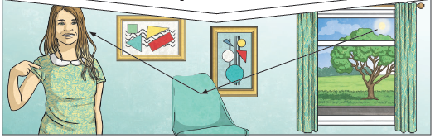  Light waves travel from sources of light in straight lines. These lights are often called rays or beams of life. The light ray is casted from a light source, reflects from an object then travels into our eyes.  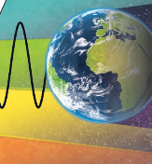  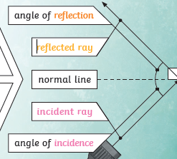  Light travels as a wave. But unlike waves of water or sound waves, it does not need a medium to travel through. This means light can travel through a vacuum – a completely airless space.  The law of reflection states that the angle of incidence is equal to the angle of reflection. Whenever light is reflected from a surface, it obeys the law.  The angle of reflection is the angle between the normal line and the reflected ray light. The angle of incidence is the angle between the normal line and the incident ray of light.  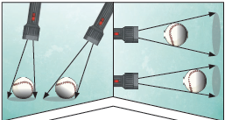  A shadow is always the same shape as the object that casts it. Shadows can be elongated or shortened depending on the angle of the light source.
 | 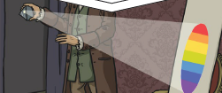  Isaac Newton shone a light through a transparent prism, separating out light into the colours of the rainbow (red, orange, yellow, green, blue, indigo and violet) – the colours of the spectrum. All the colours together merge and make visible light. | 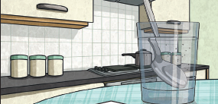  Refraction: The spoon in this water looks as if it is bent. This is because light bens when it moves from air to water. When light bends in this way, it is called refraction.
Key Vocabulary | Tier 2  - predict: to estimate that a specified thing will happen  - conclude: arrive at a judgement or opinion by reasoning  - identify: establish or indicate who or what (someone or something) is  - describe: give a detailed account of concepts  - recognise: identify from knowledge of appearance or character  - source: a place, person, or thing from which something originates or can be obtained  - justify: show or prove to be right or reasonable  - investigate: carry out a systematic or formal inquiry to discover and examine the facts so as to establish the truth | Tier 3  - absorb: take in or soak up (energy or a liquid or other substance) by chemical or physical action  - refraction: the fact or phenomenon of light, radio waves, etc. being deflected in passing obliquely through the interface between one medium and another or through a medium of varying density  - incidence (ray/line): the intersection of a line, or something moving in a straight line, such as a beam of light, with a surface  - prism: a glass or other transparent object in the form of a prism, especially one that is triangular with refracting surfaces at an acute angle with each other and that separates white light into a spectrum of colours  - visible spectrum: the portion of the electromagnetic spectrum that is visible to the human eye
Post Learning | KS3: Waves

