Crofton Junior School – Curriculum Knowledge Organiser
Unit of Work | Science – Physics – Year 5
Key Strand | Understand the Earth’s movement in space
Overview of the Unit of Work | This concept involves understanding what causes seasonal changes and day and night.
Prior Learning & Vocabulary | N/A
Sticky Knowledge | 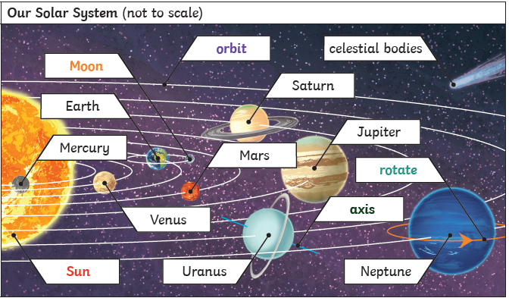  Earth rotates on its axis once every 24hours (a day). At the same time as it rotates, it orbits the sun which takes 365 ¼ days. This is rounded to a year and explains why we have a leap year every 4 years. Daytime occurs when the side of the Earth is facing the Sun; night occurs when the Earth is facing away from the Sun. It appears that the sun rises in the East and sets in the West, but the Sun does not move at all: it is due to the Earth’s rotation. The Moon orbits Earth in an oval-shaped pathway while spinning on its axis creating the Moon’s phases.  The order of the planets is: Mercury, Venus, Earth, Mars, Jupiter, Saturn, Uranus, Neptune and Pluto (classified as dwarf planet 2006)
New Vocabulary | Earth, planets, Sun, solar system, Moon, celestial body, sphere/spherical, rotate/rotation, orbit, spin, revolve, geocentric model, heliocentric model, shadow clocks, sundial, astronomical clocks night and day, Mercury, Venus, Mars, Jupiter, Saturn, Uranus, Neptune, Pluto, ‘dwarf’ planet
Post Learning | KS3 – space physics

