Purpose, Audience and Register
Purpose = The purpose is to provide detailed information about the significance of Viking Longships and how their original design made them perfect for raiding.
Audience = The audience is a young historian who is studying the Vikings.
Levels of Formality = A formal register is required. Subject-specific vocabulary should be used throughout.
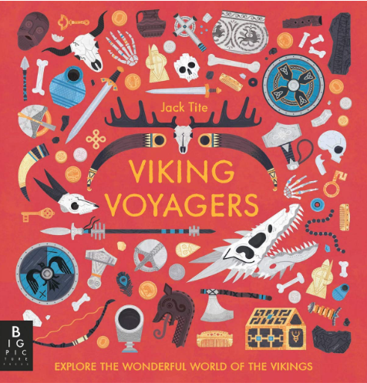
Crofton Junior School
English Knowledge Organiser Year 5 Summer Unit 3
Unit of Work | Information Text
Text Type / Genre | Non-fiction (Chronological Report)
Text Driver the Unit of Work links to | N/A

Overview of the Unit of Work including End of Unit Outcome | In discrete History lessons, the pupils will have been learning about the design of Viking Longships and the success of these in relation to their use for invasion and later settlement. Pupils will use their knowledge from these discrete history lessons, research skills and pages 44-45 of “Viking Voyagers” by Jack Tite in order to plan, draft and write an information text about the significance of Viking Longships and how their original design made them perfect for raiding. Pupils will apply a range of grammatical skills learnt throughout Year 5 and will also proof-read and edit their work following the drafting process.
Links to Reading Objectives | Pupils will read books that are structured in different ways for research purposes. They will need to know what information to look for, before they begin, to ensure their research matches the purpose of the writing they will produce. They will then retrieve and record information from these non-fiction books in order to develop their knowledge of Viking Longships before writing their information texts. Pupils will also identify how language, structure and presentation contributes to meaning by identifying the conventions of an information text. Pupils will also recap their knowledge of facts and opinions.
Prior Learning | Vocabulary, Grammar and Punctuation Knowledge:  1. In Year 5, pupils learnt that parenthesis is a word or group of words inserted into a sentence to provide additional, often non-essential, information which could be removed without affecting the sense of the sentence. It is punctuated with a pair of brackets, dashes or commas. (Year 5 revision)  2. In Year 5, pupils learnt to distinguish between statements of fact and opinion.  3. In Year 4, pupils learnt that an adverbial is a word or phrase that is used like an adverb, to modify a verb or clause. Adverbs can be used as adverbials but many other types of words and phrases can also be used this way including preposition phrases and subordinate clauses.  4. In Year 4 and 5, pupils learnt to link ideas across paragraphs using adverbials of time [for example, later], place [for example, nearby] and number [for example, secondly] or tense choices [for example, he had seen her before].  5. In Year 5, pupils learnt that a relative clause is a type of subordinate clause that adds extra information to a main clause. They are usually (but not always) introduced with a relative pronoun: that, which, who, whose, where and when.  Text Type – Information Text  - In Year 4, pupils wrote an information text in the spring term about rivers.  - In Year 3, pupils wrote an information text in the spring term about Skara Brae.
Text Type Features  (Information Text) | - It includes an introductory paragraph.  - It includes factual information based on a particular topic with subject specific vocabulary.  - It is split into paragraphs and each paragraph gives information about a different aspect of the subject. Each paragraph includes a sub-heading.  - There are a range of layout devices appropriate to structure an information text: headings, sub-headings, charts or tables.  - Pictures, captions and/or labelled diagrams can be included to provide further explanation.
Sticky Knowledge | During the summer term, time is spent revisiting key sticky knowledge from the autumn and spring terms to embed this knowledge.  The children will consolidate their understanding of:  - Parenthesis: a word or group of words inserted into a sentence to provide additional, often non-essential, information which could be removed without affecting the sense of the sentence. It is punctuated with a pair of brackets, dashes or commas.  - Adverbials: a word or phrase that is used like an adverb, to modify a verb or clause. Adverbs can be used as adverbials but many other types of words and phrases can also be used this way including preposition phrases and subordinate clauses.  - How to link ideas across paragraphs using adverbials of time [for example, later], place [for example, nearby] and number [for example, secondly] or tense choices [for example, he had seen her before].  - Relative clauses: a type of subordinate clause that adds extra information to a main clause. They are usually (but not always) introduced with a relative pronoun: that, which, who, whose, where and when.
New Vocabulary | Seafaring: regularly travelling by sea  Vessel: a container for holding something  Propelled: to drive forward or onward by or as if by means of a force that imparts motion  Navigate: to direct the way that a vehicle, especially a ship or aircraft will travel, or to find a direction across, along, or over an area of water or land  Constructed: to make or form by combining or arranging parts or elements  Mariner: a sailor  Formidable: causing fear, dread, or apprehension  Figurehead: a carving, typically a bust or a full-length figure, set at the prow of an old-fashioned sailing ship  Gruelling: extremely tiring and demanding
Post Learning | - In Year 6, pupils will write an information text about the origins of the Olympic Games in the autumn term.  - In Year 6, pupils will apply their knowledge of layout devices (such as subheadings and captions) to their newspaper article in the autumn term to retell the significant events that took place at Buckingham Palace when Hypnos visited the Queen of England. This will be inspired by the text: Who Let the Gods Out?  - In Year 6, pupils will apply their knowledge of using subject-specific vocabulary when writing a balanced argument in the summer term to discuss the key question: Should Michael be permitted to embark on the voyage around the world? This will be inspired by the text: Kensuke’s Kingdom.

