Crofton Junior School – Curriculum Knowledge Organiser
Unit of Work | Science – Physics – Year 5
Key Strand | Understand movement, forces and magnets
Overview of the Unit of Work | This concept involves understanding what causes motion.
Prior Learning & Vocabulary | Year 2 Materials: push(ing), pull(ing),  Year 3 Forces and Magnets: force, contact force, non-contact force, magnetic force, magnet, strength, bar magnet, ring magnet, button magnet, horseshoe magnet, attract, repel, magnetic material, metal, iron, steel, non-magnetic, poles, north pole, south pole
Sticky Knowledge | Forces can make an object…..  - start to move  - stop moving  - move faster  - change direction  - change its shape  - move more slowly.  Gravity is a pulling force exerted by Earth or anything else which has mass.  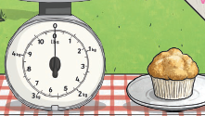  Mass is how much matter is inside an object and measured in kilograms, grams, tonnes.  Weight is how strongly gravity is pulling an object down and measured in newtons (N). |  | 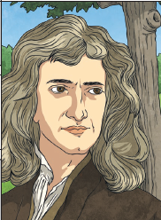  Issac Newton is famously thought of to have developed the theory of gravity and went on to write the Newton’s laws.  1st Law: An object will remain at rest, unless acted on by an unbalance force. An object in motion continues in motion with the same speed and in the same direction , unless acted upon by an unbalanced force.  2nd Law: Acceleration is produced when a force acts on mass. The greater the mass (of the object being accelerated), the greater the amount of force needed (to accelerate the object).  3rd Law: For every action, there is an equal and opposite reaction.  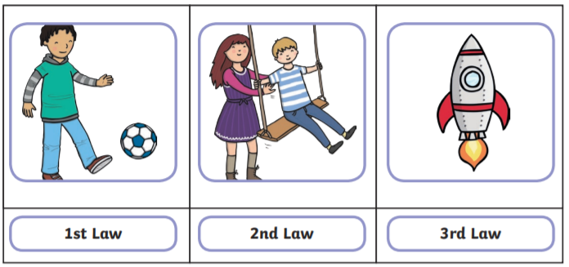  Water resistance and air resistance are forms of friction. To work with or against these, some things are built to be streamlined so that air/water can move smoothly around the object. 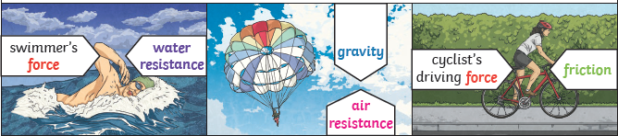
 | Pulleys use wheels to allow a small force lift a heavier load. | Gears or cogs can be sued to change speed, force or direction of a motion. |  | Levers can be used to make a small force life a heavier load by resting on a pivot.
New Vocabulary | fall, Earth, gravity, air resistance, water resistance, water resistance, friction, moving surfaces, mechanisms, levers, pulleys, gears, transfers, weight/mass
Post Learning | KS3 – Motions & Forces and KS3 – Electricity and electromagnetism

