Crofton Junior School – Curriculum Knowledge Organiser
Unit of Work | Science – Physics – Year 3
Key Strand | Understand movement, forces and magnets
Overview of the Unit of Work | This concept involves understanding what causes motion.
Prior Learning & Vocabulary | Year 2 Materials: push(ing), pull(ing),
Sticky Knowledge | A force is a push or pull that changes the motion of an object. Different surfaces create different amounts of friction. Friction is a force that acts between surfaces or objects that are moving or trying to move, across each other. The amount of friction depends on the roughness of surfaces and objects moving across each other.  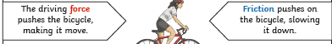  Forces will change the motion of an object. They will either make it start to move, speed up, slow it down or even make it stop. | 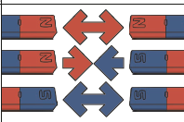  A magnet is an object which produces a magnetic force that pulls an object a certain way. A magnetic field is invisible. The same poles repel and opposite poles attract.  Some objects that contain iron, nick or cobalt are magnetic; however not all metal objects are magnetic. Objects made form plastic, wood or rubber are classed as non-magnetic.
New Vocabulary | force, contact force, non-contact force, magnetic force, magnet, strength, bar magnet, ring magnet, button magnet, horseshoe magnet, attract, repel, magnetic material, metal, iron, steel, non-magnetic, poles, north pole, south pole
Post Learning | Year 5 Forces

