Crofton Junior School – Curriculum Knowledge Organiser
Unit of Work | Science – Physics – Year 4
Key Strand | Understanding electrical circuits
Overview of the Unit of Work | This concept involves understanding circuits and their role in electrical applications
Prior Learning & Vocabulary | N/A
Sticky Knowledge | Lightning and static electricity are examples of electricity occurring naturally but for us to use electricity to power appliances it is made.  Electricity can be generated by fossil fuels, wind power, solar panels, geothermal and nuclear energy. 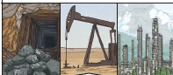 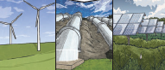 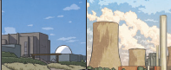  Many appliances rely on electricity whether than be from the mains electricity (socket) or a battery.  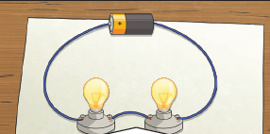  Electricity can only flow around a complete circuit that has no gaps.  A conductor of electricity is a material that will allow electricity to flow through it: metal. An insulator is a material which does not allow electricity to flow through it: wood, plastic and glass. Switches can be use to open or close a circuit.
 | There are two types of electric current:
 | 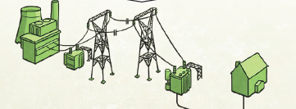  Mains electricity:  Power stations send an electric charge through wires to transformers and pylons. Then, underground wires carry the electricity into our homes via wires in the walls and out through plug sockets. | 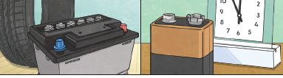  Battery electricity:  Batteries store chemicals which produce an electric current. Eventually, even rechargeable batteries will stop producing an electric current.
Key Vocabulary | Tier 2  - identify: establish or indicate who or what (someone or something) is  - label: a classifying phrase or name  - diagram: a simplified drawing showing the appearance, structure, or workings of something  - summarise: give a brief statement of the main points  - predict: to estimate that a specified thing will happen  - conclude: arrive at a judgement or opinion by reasoning  - investigate: carry out a systematic or formal inquiry to discover and examine the facts so as to establish the truth | Tier 3  - electricity: a form of energy resulting from the existence of charged particles  - appliances/devices: a device or piece of equipment designed to perform a specific task  - mains: the source of public water, gas, or electricity supply through pipes or cables  - plugs: a device for making an electrical connection between an appliance and the mains  - electrical circuit: path for transmitting electric current. An electric circuit includes a device that gives energy to the charged particles constituting the current, such as a battery or a generator; devices that use current, such as lamps, electric motors, or computers; and the connecting wires or transmission lines  - complete circuit: an uninterrupted path for electrons to flow from an energy source (i.e. battery or household power), through a device and back to the source  - circuit diagram: a graphical representation of an electrical circuit  - components: a part or element of a larger whole  - cell/battery: a container consisting of one or more cells, in which chemical energy is converted into electricity and used as a source of power  - positive/negative: containing, producing, or denoting an electric charge opposite to that carried by electrons  - connect/connection: link to a power or water supply  - short circuit: an electrical circuit in a device of lower resistance than that of a normal circuit  - loose connection: a defective or imperfect connection in electric wiring, as in a headphone cable or plug  - wire: metal drawn out into the form of a thin flexible thread or rod  - crocodile clip: a sprung metal clip with long, serrated jaws, used attached to an electric cable for making a temporary connection to a battery or other component  - bulb: provides light  - bright: giving out or reflecting much light  - dim: not shining brightly or clearly  - switch: a device for making and breaking the connection in an electric circuit  - buzzer: an electrical device that makes a buzzing noise and is used for signalling  - conductor: a material or device that conducts or transmits heat or electricity  - insulator: a substance or device which does not readily conduct electricity  - metal: a solid material which is typically hard, shiny, malleable, fusible, and ductile, with good electrical and thermal conductivity  - non-metal: an element or substance that is not a metal
Post Learning | Year 6 : electricity

