Crofton Junior School – Curriculum Knowledge Organiser
Unit of Work | Science – Physics – Year 3
Key Strand | Understanding light and seeing
Overview of the Unit of Work | This concept involves understanding how light and reflection affect sight.
Prior Learning & Vocabulary | Year 2 (materials): transparent, opaque, translucent
Sticky Knowledge | 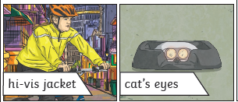  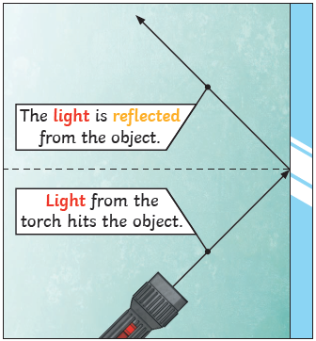  We need light to be able to see things. Light travels in a straight line. When light hits an object, it is reflected. If the reflected light hits our eyes, we can see the object. Some surfaces and materials reflect light well; other materials do not reflect materials well. Reflective materials can be very useful. The surfaces that reflect light best are smooth, shiny and flat.  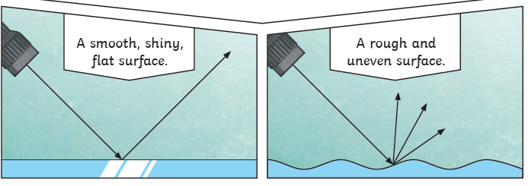 |  | 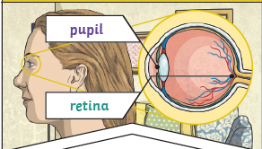  The pupils control the amount of light entering the eyes. If too much light enters, then it can damage the retina. To help protect the eyes, you can wear a hat with a wide brim and sunglasses with a UV rating.
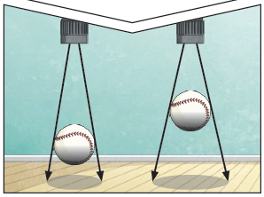
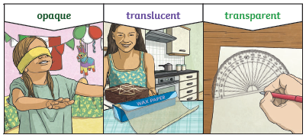
A shadow is caused when light is blocked by an opaque object. When a light source is to one side of an object, the shadow will appear on opposite side.

Key Vocabulary | Tier 2  - predict: to estimate that a specified thing will happen  - conclude: arrive at a judgement or opinion by reasoning  - identify: establish or indicate who or what (someone or something) is  - describe: give a detailed account of concepts  - recognise: identify from knowledge of appearance or character  - source: a place, person, or thing from which something originates or can be obtained  - investigate: carry out a systematic or formal inquiry to discover and examine the facts so as to establish the truth | Tier 3  - dark/darkness: with little or no light  - reflect: (of a mirror or shiny surface) show an image of  - reflective: providing a reflection; capable of reflecting light  - mirror: a surface, typically of glass coated with a metal amalgam, which reflects a clear image  - shadow: a dark area or shape produced by a body coming between rays of light and a surface  - block: put an obstacle (opaque solid) in the way  - direct/direction: extending or moving from one place to another without changing direction or stopping  - ray: each of the lines in which light may seem to stream from the sun or any luminous body, or pass through a small opening  - retina: a layer at the back of the eyeball that contains cells sensitive to light, which trigger nerve impulses that pass via the optic nerve to the brain, where a visual image is formed  - pupil: the dark circular opening in the centre of the iris of the eye, which varies in size to regulate the amount of light reaching the retina
Post Learning | Year 6 : Light

