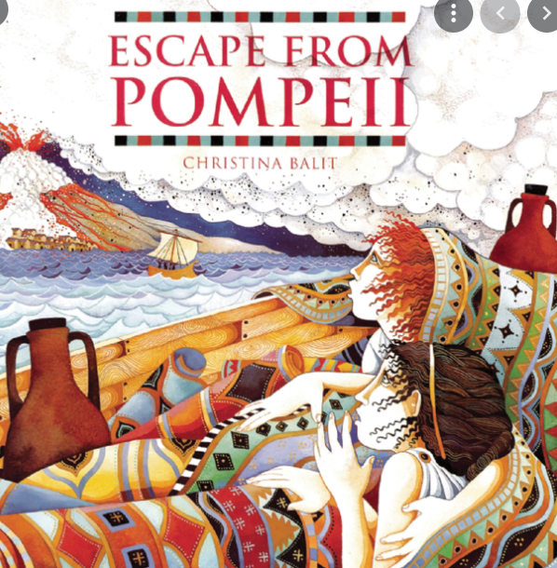
Purpose, Audience and Register
Purpose = The purpose is to retell the whole text with different main characters to entertain and engage the audience.
Audience = The audience are children who are interested in action and adventure narratives and the eruption of Mount Vesuvius.
Levels of Formality = An informal register is required.
Crofton Junior School
English Knowledge Organiser Year 3 Summer Unit 1
Unit of Work | Narrative
Text Type / Genre | Fiction – Narrative
Text Driver the Unit of Work links to | Escape from Pompeii by Christina Balit

Overview of the Unit of Work including End of Unit Outcome | Pupils will be immersed in the story Escape from Pompeii by Christiana Balit. They will read and learn about the key themes in the story (friendship and survival). They will make predictions and inferences about the story based on the information they have . After this, pupils will recall their grammatical knowledge of tenses, prepositions and subordinate conjunctions; they will also learn the skill of incorporating purposeful direct speech into their work through a variety of application tasks. The children will consider how the author has developed the characters in this fictional interpretation of a real-life event. Following this, children will construct a story mountain to build cohesion and support them as a tool to write a first-person narrative from the perspective of their own fictional character in relation to the day of the eruption of Mount Vesuvius. They will apply their knowledge of paragraphs, prepositions and main and subordinate clauses to plan, draft and write their first-person narrative. Pupils will reflect upon their initial draft and begin to make meaningful edits to up level this further with a particular focus on the purposeful use of language. They will ensure grammatical techniques are used effectively to leave an impression on the reader. Finally, pupils will recall their knowledge of proof-reading to allow them to make corrections to errors in spelling, punctuation and grammar.
Links to Reading Objectives | Pupils will use their prediction, retrieval and inference skills to explore the characters of Livia and Tranio during their escape from Pompeii following the eruption of Mount Vesuvius. They will explore the meaning of words looking at the impact that they have on the reader to ensure that they are aware of effective language choices to maximise impact. They will also analyse the characters’ thoughts, feelings and actions within the text and they will explore the five senses to immerse themselves in the eruption of the volcano.
Prior Learning | Vocabulary, Grammar and Punctuation Knowledge:  - In Year 3, pupils have developed their understanding of subordinating conjunctions: when, if, because and although. Children have focused on subordinate clauses within sentences and they have started to manipulate sentences by moving the position of the subordinate clauses to the start of the sentences.  - In the autumn and spring terms of Year 3, children learnt about prepositions - a word or phrase used to tell you when or where something is in relation to something else.  Text Type – Narrative  - In Year 3, pupils have drafted a range of narratives in the autumn and spring terms including in the form of a diary, setting description and character description from a first-person perspective.
Text Type Features  (Narrative) | - A narrative will create a picture in the reader’s mind through powerful description, introduce any characters and create the atmosphere for the story.  - A story opening should make the reader want to read on. This is known an a 'hook'. It will capture the reader’s attention and leave the reader with questions making the reader want to continue reading.  - A description must use powerful and effective expanded noun phrases in order to create the required atmosphere. It must include references to the five senses (touch, smell, sight, sound and taste) and descriptions will use ambitious vocabulary.
Sticky Knowledge | During the summer term, time is spent revisiting key sticky knowledge from the autumn and spring terms to embed this knowledge.  The children will learn:  - That inverted commas are use to punctuate direct speech. Direct speech is a sentence where the exact words that are spoken are written in inverted commas. Direct speech can be used in multiple written texts. It is widely used in fiction where it can help readers to understand characters better.  - A preposition is a word that tells you when or where something happens. They can also tell you why things happen. Examples of prepositions include words like after, before, on, under, inside and outside.  - How to use the progressive form of verbs in the present tense to describe an ongoing activity in the present i.e. actions in progress and ones that are currently happening.  - How to use the progressive form of verbs in the past tense to describe a continuing action or action in progress that started in the past.  Recap  - Subordinating conjunctions join a main clause and a subordinate clause together to form a multi-clause sentence.  - The subordinate clause starts with a subordinating conjunction such as although, until, while, when, if, before, after, once, because and as.  - The subordinate clause depends on the main clause for meaning – it cannot stand alone.  - The subordinate clause can be manipulated by using a comma to separate the subordinate clause from the main clause when the subordinate clause is at the start of the sentence.  - Paragraphs are a way to group related material.
New Vocabulary | - direct speech - a sentence in which the exact words spoken are reproduced in inverted commas (also known as quotation or speech marks)  - Mount Vesuvius - a volcano on the south western coast of Italy close to the city of Pompeii  - protector – a person or thing that is intended to protect  - tremors – a small earthquake that causes the ground to tremble  - harbour – a part of a body of water where ships are kept  - eruption - A volcano is an opening in the Earth's crust that allows magma, hot ash and gases to escape.
Post Learning | - In Y3 in the summer term, pupils will retell a significant event from the perspective of Lila to entertain and engage the audience and to express her personal thoughts and feelings. This will be inspired by the text: The Firework Maker’s Daughter.  - In Y4 in the autumn term, pupils will write a first-person narrative to describe Scrooge’s first encounter with the Ghost of Christmas Past. This will be inspired by the text: A Christmas Carol.  - In Y4 in the spring term, pupils will write their own ending when Ali returns to the village following the discovery of Tutankhamun’s tomb. This will be inspired by the text: I was there… Tutankhamun’s tomb.  - In Y4 in the summer term, pupils will write the next chapter based on Ruby encountering the leopard in chapter 24 of the following text: When the Mountains Roared.  - In Y5 in the spring term, pupils will write a narrative to rewrite an event in the story from the perspective of the main character. This will be inspired by the text: The Explorer.  - In Y5 in the summer term, pupils will write a narrative to describe the duel between Grendel and Beowulf. This will be inspired by the text: Beowulf.  - In the spring term of Y6, pupils will write a narrative detailing the ‘Dark Deed’ where King Duncan is murdered by his cousin. This will be inspired by the text: Macbeth.  - In the summer term of Y6, pupils will write a first-person narrative from the perspective of Michael to describe the island from his viewpoint when he first wakes up on the beach following his ordeal at sea. This will be inspired by the text: Kensuke’s Kingdom.

