Crofton Junior School – Curriculum Knowledge Organiser
Unit of Work | Science – Biology – Year 3
Key Strand | Understand plants
Overview of the Unit of Work | This concept involves becoming familiar with different types of plants, their structure and reproduction.
Prior Learning & Vocabulary | Year 1 (plants): leaf/leaves, flower, blossom, petal, fruit, berry, root, bulb, seed, trunk, branch, stem, bark, stalk,  Year 2 (plants): water, light/dark, damp/wet/dry, hot/warm/cool/cold, temperature, grow/growth, healthy
Sticky Knowledge | 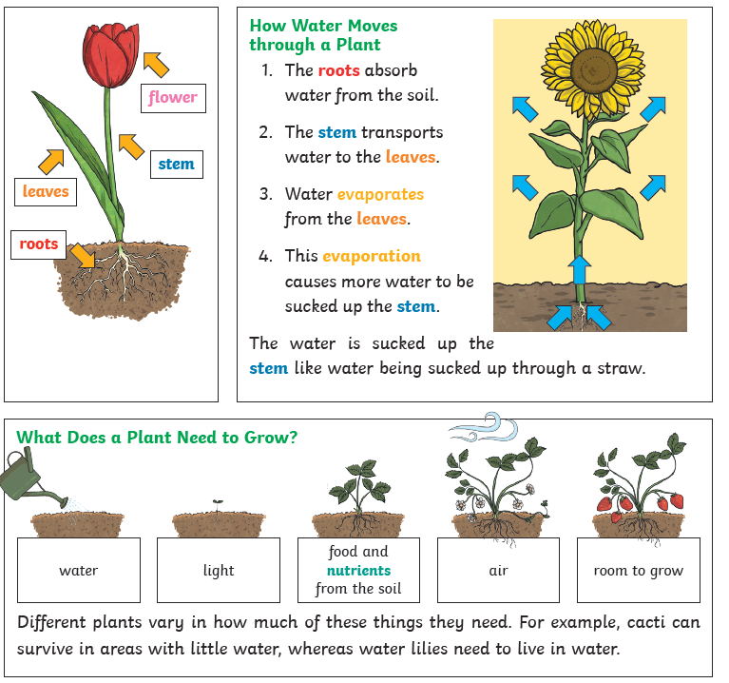 | 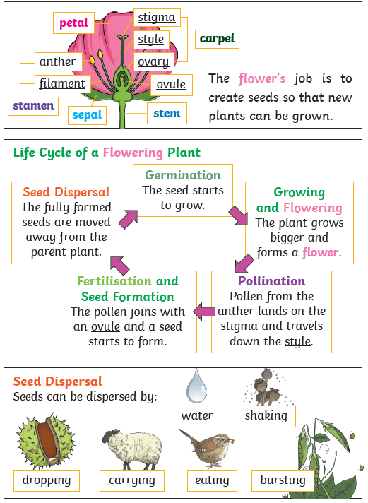
Key Vocabulary | Tier 2  - predict: to estimate that a specified thing will happen  - conclude: arrive at a judgement or opinion by reasoning  - demonstrate: give a practical exhibition and explanation  - summarise: give a brief statement of the main concepts  - describe: give a detailed account of concepts |  | Tier 3  - function: purpose/role of parts of the plants  - air: the invisible gaseous substance surrounding the earth  - nutrients: a substance that provides nourishment essential for the maintenance of growth of plants  - soil: the upper layer of earth in which plants grow,  - fertiliser: a chemical or natural substance added to soil or land to increase its fertility  - transported: take or carry from one place to another  - life cycle: the series of changes in the life of an organism including reproduction  - pollination: the transfer of pollen to a stigma, ovule, flower, or plant to allow fertilization  - seed formation: a seed is formed when fertilised ovule divides by mitosis  - seed dispersal: the mechanism by which plant seeds are transported to new sites for germination and the establishment of new individuals
Post Learning | Year 5: Living things (related knowledge)  KS3: material cycles and energy

