Crofton Junior School – Y4 History Knowledge Organiser
Unit of Work | Victorians and a Local Study
Text Driver the Unit of Work Links to | Rosie Revere Engineer (Andrea Beaty)  A Christmas Carol (Charles Dickens)
Key Strand | Inventions and Legacy
Timeline | 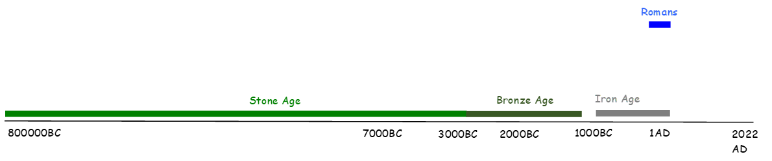  Victorians
Overview of the Unit of Work | During the unit of work, the children will learn about the Victorian Era, and where this time period is placed on a timeline of British and World History. The children will understand the Victorian era was a time of significant change in technology and trade. Agriculture was no longer the primary source of work, and people flocked to growing urban areas and cities to find jobs. They will compare and contrast the difference between urban and rural settlements before and after the Industrial Revolution to show an understand of how this time period left a legacy of change. The children will learn that the Industrial Revolution saw many significant inventions such as photography, typewriters, telephone and railway networks, with a focus particularly on the steam engines, bridges and tunnels as Isambard Kingdom Brunel’s inventions completely change the way people lived, how they worked and also understand the impact they had on the era and after. The children will learn that the railway network grew rapidly and the railway system offered new chances for travel, holidays, transporting goods, developing businesses and the growth of towns and cities (Legacy). They will understand the impact this had on different societies (rich and poor) – on children and factory owners and workers - and how their experiences differed. Coal was very important to the Victorians because it was their main source of power. They used it for: driving machinery, moving locomotives and steamships, cooking and heating.  As part of the Local History study, the pupils will understand the significance of their local pit villages (Walton, Sharlston, Chevet, Oakenshaw, Heath Common, Wragby) and their contribution to coal mining in the Victorian period. They will learn about the job roles in a Victorian mine – Trapper, Thruster, Hurrier and Getter – to describe and explain these roles in detail. After the visit to the National Coal Mining Museum, the children will learn the different between primary and secondary sources, and learn the Story of Jimmy – a twelve years old ‘trapper’ working in the coal mines of the North East in the 1840s. They will read and use evidence taken from the 1842 Parliamentary Commission’s Report on conditions in the mines in order to create a piece of written work where they will answer the ‘Big Question’ – by using multiple sources of evidence to explain the subject of child labour in Victorian coal mines. They will understand about the impact of the Huskar Colliery mining accident in Barnsley had on families, the community and the country and how various Acts changed working conditions for the future (1842 Coal Mining Act). The children will have the opportunity to express their thoughts on whether life changed for the better for working families when the 1842 Coal Mining Act was passed, suggesting and explaining both positivise and negatives of the Act being passed.
Prior Learning & Vocabulary | During Year 3, pupils will have learnt about inventions and legacy of the Roman period. The children will know that the Romans left a significant legacy behind on how life is lived today, including the development of roads for transport and how trade became important.
Sticky Knowledge | Inventions and Legacy  The Victorians.  The pupils will learn:  - About the time period of the Victorians and where it fits in world history.  - During the Industrial Revolution (a time of change from agriculture to industry), agriculture was no longer the primary source of work, and people flocked to growing urban areas and cities to find jobs.  - The shift from agriculture to industry was made possible by several significant innovations and the development of a skilled workforce.  - There were key Victorian developments: bridges and railways and the impact these had on society. The importance of Isambard Kingdom Brunel’s inventions and he impact they had on the era and after.  - The railway network grew rapidly and the railway system offered new chances for travel, holidays, transporting goods, developing businesses and the growth of towns and cities (Legacy). At the time, the invention wasn’t seen as a positive for everyone (such as famers and rural living), and different societies had different feelings on the growth of the railways.  - Coal was very important to the Victorians because it was their main source of power. They used it for: driving machinery, moving locomotives and steamships, cooking and heating.  - From the mid-18th century industrial machines were being developed, changing the way in which goods were manufactured. Factories, built to house the machinery, dominated Britain’s urban areas and were the workplace of many. Some of the Victorian factories were incredibly large and employed more than 500 people.  - A workhouse was a huge building built for very poor people to live and work. They were poor for a number of reasons: ill health, old age, single mothers, orphaned children or purely because they couldn’t find work. Able-bodied, unemployed people had no choice but to enter a workhouse. The alternative was prison!  - Young children would work down in the mines and conditions were very dangerous with many accidents.  - What life was like down the mine for men, women and children (linked to the NCM trip)  Local Study- Wakefield and Barnsley Area.  - About the location of local pits and collieries  - About The structure of mines underground  - In 1838, a freak accident occurred at Huskar Colliery in Silkstone, near Barnsley, and the impact that this had on the local community.  - The disaster shocked the nation, including the young Queen Victoria, and led to a bill being put through Parliament in 1842 by Lord Ashley (later Lord Shaftesbury) which prevented women and children from working down mines. Queen Victoria set up a Royal Commission to enquire into women and children working in coal mines.  - The Children’s Act that was passed, and other laws to protect lives.
End of Unit Outcome | By the end of the unit of work, the children will apply their knowledge of The Victorian Era, and the effects and impact coal mining had on the local area by taking part in a class debate (delivered by the use of drama) to take on the roles of people present in the Huskar Colliery Inquest to decide whether the verdict was fair or not.
Key Vocabulary | Tier 2  economy: the wealth a country gets from business and industry  parliament: a group of people who make or change laws  representation: speaking on behalf of someone else  conditions: the circumstances or factors affecting the way in which people live or work, especially with regard to their well-being.  tragic: something that makes people very sad  disaster: a sudden accident or a natural catastrophe that causes great damage or loss of life.  ventilation: the movement of fresh air  workforce: people available to do a job  innovations: new ways of doing something  Tier 3  commission: a task given to a person or group  pit: a coal mine.  - colliery: a coal mine and the buildings and equipment associated with it.  shaft: a long, narrow, typically vertical hole that gives access to a mine, accommodates a lift in a building, or provides ventilation.
Post Learning | In year 5, the children will learn the legacy left from the Mayan’s discovery of chocolate.  In year 6, the children will learn the legacy left from the Ancient Greek and the Olympic games.

