Crofton Junior School – Curriculum Knowledge Organiser
Unit of Work | Science – Biology – Year 3
Key Strand | Understand plants
Overview of the Unit of Work | This concept involves becoming familiar with different types of plants, their structure and reproduction.
Prior Learning & Vocabulary | Year 1 (plants): leaf/leaves, flower, blossom, petal, fruit, berry, root, bulb, seed, trunk, branch, stem, bark, stalk  Year 2 (plants): water, light/dark, damp/wet/dry, hot/warm/cool/cold, temperature, grow/growth, healthy
Sticky Knowledge | 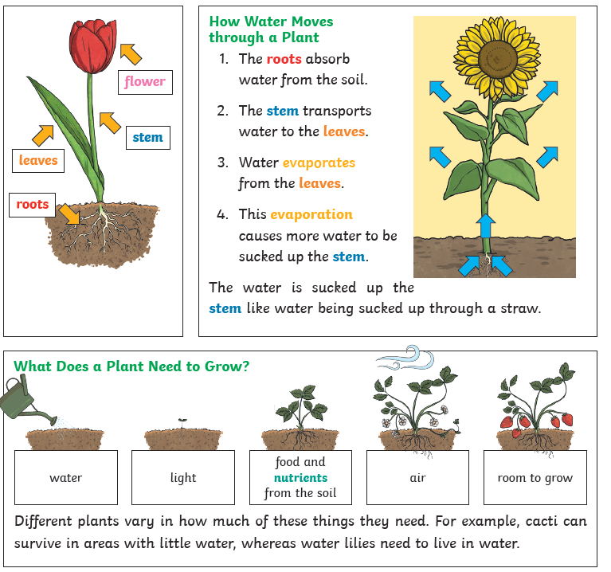 | 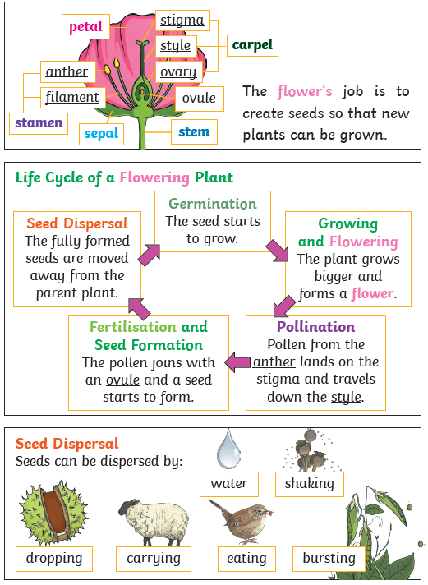
New Vocabulary | part, role, air, nutrients, soil, fertiliser, transported, life cycle, pollination, seed formation, seed dispersal
Post Learning | Year 5: Living things (related knowledge)  KS3: Material cycles and energy

