Crofton Junior School – Curriculum Knowledge Organiser
Unit of Work | Science – Chemistry – Year 3
Key Strand | Understand materials (rocks)
Overview of the Unit of Work | This concept involves becoming familiar with range of materials, their properties, uses and how they may be altered or changed.
Prior Learning & Vocabulary | Year 1 Materials  Year 2 Materials
Sticky Knowledge | There are three types of rock: Igneous, Sedimentary and Metamorphic  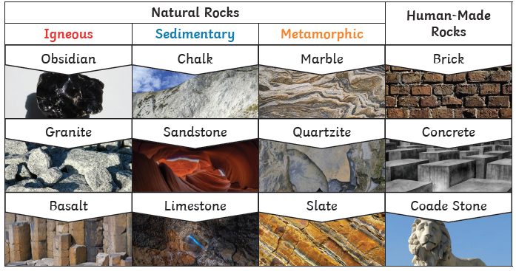 | Caves are formed when water permeates through the base rock and erodes some of the rock away. Over thousands of years these caves can become very large.  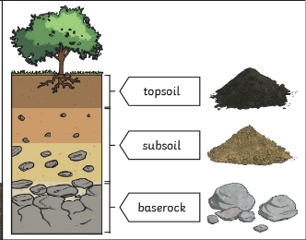  Soil is the uppermost layer of the Earth. It is a mixture of different things.  - minerals  - air  - water  - organic matter (including living and dead plants and animals)
 | 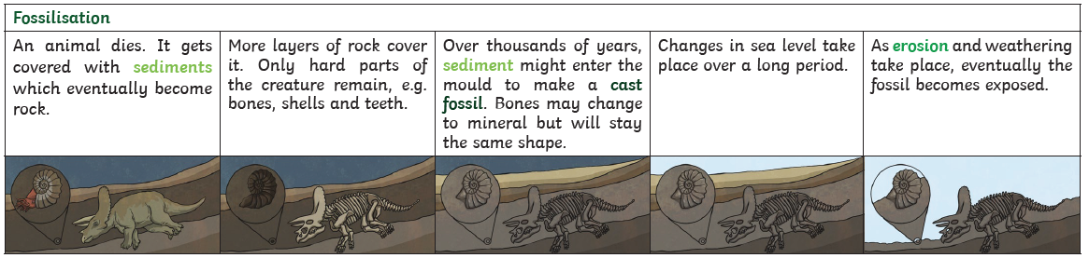
New Vocabulary | rock, stone, pebble, boulder, soil (sandy/clay/chalky), fossils, grains, crystals, hard/soft, texture, absorb water, permeable, impermeable, marble, chalk, granite, sandstone, slate, peat, igneous, sedimentary, metamorphic, fossilisation, sediment
Post Learning | Year 5: Materials  Year 6: Evolution and Inheritance

