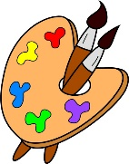
Crofton Junior School – Art Knowledge Organiser – The Magic of Chocolate – Year 5 Autumn Term

Unit of Work | Art – The Magic of Chocolate – Making a chocolate brand (Pop Art)
Text Driver the Unit of Work Links to | Charlie and The Chocolate Factory
Key Strand | Inspiration from the Greats  Develop Ideas  Master Techniques – Painting
Overview of the Unit of Work | Pupils will learn about the art style ‘Pop Art’ and how it began in the 1950s but only became popular in the 1960s. Even though Pop Art began in the UK, it was most successful in the USA. Pupils will learn specifically about the British artist Andy Warhol and the successes he had as a Pop Artist. The pupils will look at other pop artists; Roy Lichtenstein, Eduardo Paolozzi, David Hockney and Pauline Boty and discuss their style.  Pupils will also collect information, sketches, resources, and present ideas imaginatively in a sketchbook and comment on the artworks with a fluent grasp of visual language. Additionally, they will sketch (lightly) before painting to combine line and colour and use the qualities of acrylic paints to create visually interesting pieces.  Pupils will create a final piece of artwork that will be used for branding a chocolate product.
Prior Learning & Vocabulary | During the Autumn and Spring Term in year 3, the children will have learnt about the great artists Wassily Kandinsky and Henry Moore. Additionally, in the Summer Term of year 4, the children will have learnt about the great artist Claude Monet. They will have learnt painting brush techniques and how to experiment with colour.  Vocabulary: Inspiration, replicate, technique, artist, original, study, influence, brush, shape, texture, pattern, line, wash, background, experiment, mood, mix, watercolour.
Sticky Knowledge | Pupils will learn:  - How Pop Art became popular in the UK and USA but there was a difference between the inspiration and style in the two countries.  - The famous artists associated with Pop Art – Andy Warhol, Roy Lichtenstein, Eduardo Paolozzi, David Hockney and Pauline Boty.  - About Andy Warhol and how he was possibly the most famous Pop Artist, using a wide range of media, he became highly respected and his studio frequently visited – especially by celebrities.  - How Andy Warhol was inspired by beauty and things that were modern. He was also intrigued by commercial products and how some of these, such as a can of coke or a tin of soup, were bought by rich and poor alike.  - How to collect information, sketches, resources, and present ideas imaginatively in a sketchbook as well as to comment on the artworks with a fluent grasp of visual language.  - To sketch (lightly) before painting to combine line and colour and to use the qualities of acrylic paints to create visually interesting pieces.  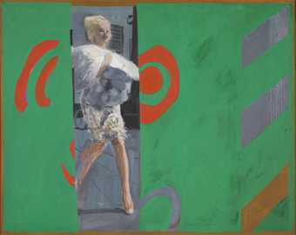  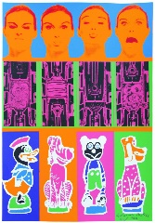  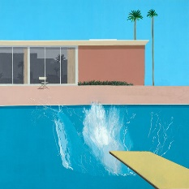  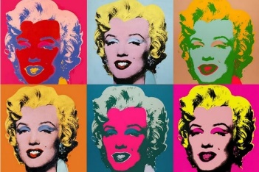  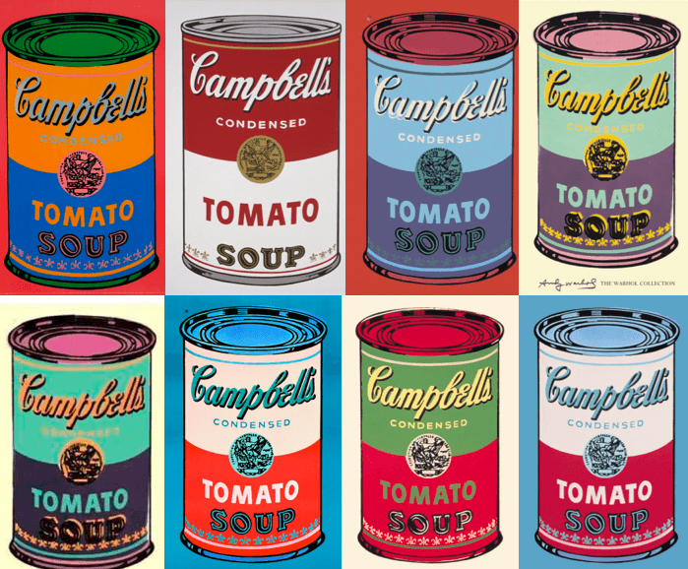
End of Unit Outcome | The children will design the outer packaging of a sweet/chocolate box using the Pop Art style.
New Vocabulary | Tier 2  commercial: made to be sold to the public  elite: powerful, rich people  masses: ordinary, common people  ridiculed: made fun of, mocked  enhance: intensify, increase, or further improve the quality, value, or extent of  icons: people or objects seen as symbols of the latest trends  distinguished: very successful, with a good reputation  intrigued: interested by something and wanting to know more about it  Tier 3  banal: ordinary and not interesting  mundane: everyday, common and not attractive  portfolio: a set of pictures or examples of a person’s work  vivacious: lively, exciting and attractive  tertiary colours: colours formed by mixing a primary and a secondary colour or two secondary colours  palette: a thin board where an artist mixes colour
Post Learning | During the Spring Term of year 6, pupils will look at painting techniques again through the great artist Henri Rousseau.

