 | Text Driver | Autumn  Units of Work (text types) | Text Driver | Spring  Units of Work (text types) | Text Driver | Summer  Units of Work (text types)
Summary of Progression
By Year 6, children are able to draw on their full range of learning experiences at Crofton Junior School, including their broad range of vocabulary, varied writing skills (including a range of grammar and punctuation skills), knowledge of text features and ideas gathered from their school experiences. They show their depth of understanding by writing in a range of styles and for a variety of purposes, and can sustain reading longer and more complex novels. The texts studied in Year 6 are carefully selected to support children to broaden their depth of knowledge and understanding of a range of complex and more mature themes.
Crofton Junior School - Year 6 | Who Let the Gods out?  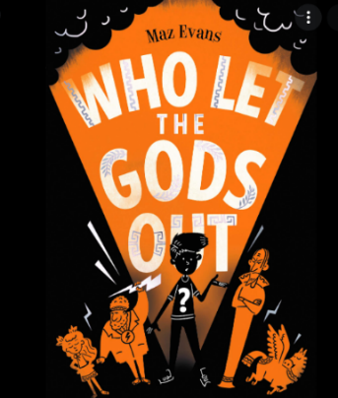  Author = Maz Evans  Modern Fiction (Historical and mythical link) | Unit of Work: Diary Entry  Non-fiction (Autobiographical writing)  Purpose: Recount events and Entertain  The purpose is to recall what happened to Elliot Hooper from a first-person perspective to allow him to organise and articulate his thoughts and feelings after his first encounter with Virgo. | Macbeth  Author = William Shakespeare  (Adapted by Jon Blake)  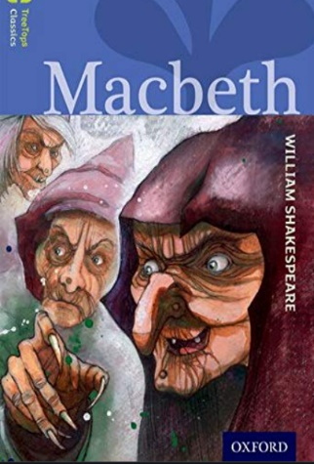  Classic Literature/ Horror | Unit of Work: Poetry – The Witches’ Spell  Performance Poetry  Purpose: Entertain  The purpose is to perform the Witches’ spell from Macbeth in order to entertain and deliberately foreshadow future events which will engage the reader. | Kensuke’s Kingdom  Author = Michael Morpurgo  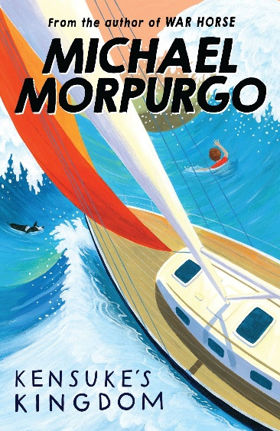  Modern Fiction/ Adventure | Unit of Work: Balanced Argument  Non-fiction (Argument text)  Purpose: Inform and Persuade  The purpose is to present detailed evidence in support and in opposition of the key question: Should Michael be permitted to embark on the voyage around the world? This information will inform the reader of different beliefs which will support them to make an informed decision regarding their personal viewpoint.
 |  | Unit of Work: Newspaper Article  Non-fiction (Recount)  Purpose: Inform (Recount events)  The purpose is to retell the significant events that took place at Buckingham Palace when Hypnos visited the Queen of England so that the immortal community are informed and up-to-date with recent news. |  | Unit of Work: Character Description  Fiction  Purpose: Entertain  The purpose is to describe the character of Lady Macbeth from the perspective of a witch to express her appearance and key characteristics and to entertain the audience – the witching community who listen to the prophecies foretold by the witch.
 |  | Unit of Work: Information Text  Non-fiction (Non-chronological report)  Purpose: Inform  The purpose is to provide detailed information about the origins of the Olympic Games and how they have changed overtime to create the modern Olympic Games in order to help the reader to fully understand this. |  | Unit of Work: Letter  Non-fiction (Persuasion)  Purpose: Persuade  The purpose is to argue (from the perspective of Lady Macbeth) that Macbeth should kill the king and seize the throne himself. The aim is to encourage the reader (Macbeth) towards the same way of viewing the predicament. |  | Unit of Work: First Person Narrative  Fiction  Purpose: Entertain  The purpose is to entertain by describing the island from the perspective of Michael when he first wakes up on the beach following his ordeal at sea. Michael’s initial impressions, thoughts and feelings will be detailed.
Unit of Work: Extended Narrative
Fiction

Purpose: Entertain

The purpose is to rewrite Chapter 4 (Dark Deed) from Macbeth where King Duncan is brutally murdered by his cousin, Macbeth, to entertain and engage the audience. Extended dialogue will be included to advance the action.

