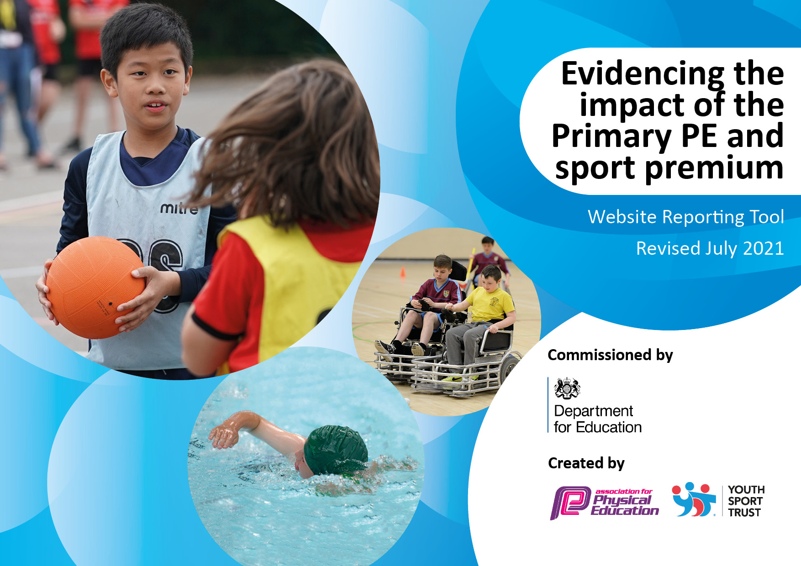
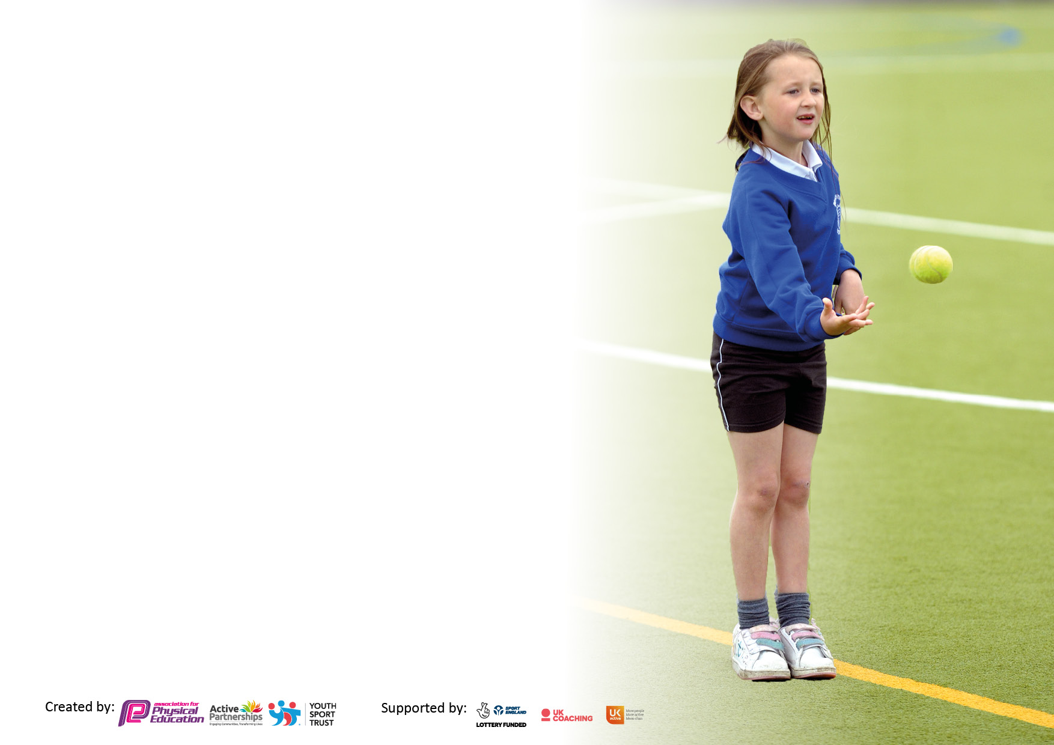

It is important that your grant is used effectively and based on school need. The Education Inspection Framework makes clear there will be a focus on ‘whether leaders and those responsible for governors all understand their respective roles and perform these in a way that enhances the effectiveness of the school’.

Under the Quality of Education Ofsted inspectors consider:
Intent - Curriculum design, coverage and appropriateness
Implementation - Curriculum delivery, Teaching (pedagogy) and Assessment
Impact - Attainment and progress

To assist schools with common transferable language this template has been developed to utilise the same three headings which should make your plans easily transferable between working documents.

Schools must use the funding to make additional and sustainable improvements to the quality of Physical Education, School Sport and Physical Activity (PESSPA) they offer. This means that you should use the Primary PE and sport premium to:

- Develop or add to the PESSPA activities that your school already offer
- Build capacity and capability within the school to ensure that improvements made now will benefit pupils joining the school in future years
- The Primary PE and sport premium should not be used to fund capital spend projects; the school’s budget should fund these.

Pleasevisitgov.ukfortherevisedDfEguidanceincludingthe5keyindicatorsacrosswhichschoolsshoulddemonstrate animprovement.Thisdocumentwillhelpyoutoreviewyourprovisionandtoreportyourspend.DfEencouragesschools to use this template as an effective way of meeting the reporting requirements of the Primary PE and sport premium.

We recommend you start by reflecting on the impact of current provision and reviewing the previous spend.

Schools are required to publish details of how they spend this funding, including any under-spend from 2019/2020, as well as on the impact it has on pupils’ PE and sport participation and attainment. All funding must be spent by 31st July 2022.

We recommend regularly updating the table and publishing it on your website throughout the year. This evidences your ongoing self-evaluation of how you are using the funding to secure maximum, sustainable impact. Final copy must be posted on your website by the end of the academic year and no later than the 31st July 2021. To see an example of how to complete the table please click HERE.

Details with regard to funding
Please complete the table below.

Total amount carried over from 2019/20 | £7,103
Total amount allocated for 2020/21 | £ 18, 370
How much (if any) do you intend to carry over from this total fund into 2021/22? | £7,647 + £7,103 = £14,750
Total amount allocated for 2021/22 | £ 18, 360
Total amount of funding for 2021/22. To be spent and reported on by 31st July 2022. | £ 18, 360 + £14,750 = £33,110
Swimming Data
Please report on your Swimming Data below.

Meeting national curriculum requirements for swimming and water safety.

N.B. Complete this section to your best ability. For example you might have practised safe self-rescue techniques on dry land which you can then transfer to the pool when school swimming restarts.
Due to exceptional circumstances priority should be given to ensuring that pupils can perform safe self rescue even if they do not fully meet the first two requirements of the NC programme of study
What percentage of your current Year 6 cohort swim competently, confidently and proficiently over a distance of at least 25 metres?  N.B. Even though your pupils may swim in another year please report on their attainment on leaving primary school at the end of the summer term 2020.  Please see note above | 55/60 - 92%
What percentage of your current Year 6 cohort use a range of strokes effectively [for example, front crawl, backstroke and breaststroke]?  Please see note above | 44/60 - 73%
What percentage of your current Year 6 cohort perform safe self-rescue in different water-based situations? | 43/60 - 72%
Schools can choose to use the Primary PE and sport premium to provide additional provision for swimming but this must be for activity over and above the national curriculum requirements. Have you used it in this way? | No

Action Plan and Budget Tracking
Capture your intended annual spend against the 5 key indicators. Clarify the success criteria and evidence of impact that you intend to measure to evaluate for pupils today and for the future.

Academic Year: 2021/ 2022 | Total fund allocated: | Date Updated: October 2022
Key indicator 1: The engagement of all pupils in regular physical activity – Chief Medical Officers guidelines recommend that primary school pupils undertake at least 30 minutes of physical activity a day in school |  |  |  | Percentage of total allocation:
 |  |  |  | £16,173 - 49%
Intent | Implementation |  | Impact
Your school focus should be clear what you want the pupils to know and be able to do and about  what they need to learn and to  consolidate through practice: | Make sure your actions to achieve are linked to your intentions: | Funding allocated: | Evidence of impact: what do pupils now know and what can they now do? What has changed?: | Sustainability and suggested next steps:
All pupils are provided with a wide range of opportunities to be physically active and they will understand how physical activity can help them to adopt a healthy and active lifestyle  All pupils are encouraged to make healthy lifestyle choices.  Most pupils engage in at least 60 minutes of physical activity a day, of which 30 minutes should be in school  There is a recognition of the benefits of Physical Activity by all stakeholders including how Physical Activity:  - has a huge impact on the cognitive function of the brain including retention and recall  - improves leaning behaviours such as concentration levels and focus  - supports pupils to develop better self-belief and self-image  - contributes to whole child development  All stakeholders clearly understand being active is the key - active children achieve more | Employment of PC to deliver active lunch times for 30 mins per day  Budget to purchase play time and lunch time equipment including storage  Complete remedial works to the playground in order to :  - Improve health & safety for pupils and staff during break and lunchtimes.  - Create more purposeful and active playground areas, which engage all children.  - Create areas which will enhance PE lessons and promote opportunities for active learning across all areas of the curriculum. | £1991  £2500  £11,682 budget | The use of an adult to organise lunch time games continues to be an effective manner in ensuring children are taking part in more purposeful physical activity.  Providing children with a variety of equipment to use at break and lunch times is effective in encouraging more children to be active, enabling children to organise independent activities and widen their experience of different games/skills.  Significant impact on the number of pupils being active. The ‘mugga’ has provided a safe space for children to play more competitive games thereby allowing other children space to use playground markings, traverse walls and play less-competitively if they wish. | Provide playground games training for another so that activities can run throughout the split lunchtime period.  Continue to replenish equipment due to wear and tear.  Continue to ensure that all children are provided with the opportunity to access the mugga.  Playground games training for lunchtime supervisors so that they can further encourage and organise play with the children.
Key indicator 2: The profile of PESSPA being raised across the school as a tool for whole school improvement |  |  |  | Percentage of total allocation:
 |  |  |  | £600 - 2%
Intent | Implementation |  | Impact
Your school focus should be clear what you want the pupils to know and be able to do and about  what they need to learn and to  consolidate through practice: | Make sure your actions to achieve are linked to your intentions: | Funding allocated: | Evidence of impact: what do pupils now know and what can they now do? What has changed?: | Sustainability and suggested next steps:
The profile of PE, sport and physical activity is raised across the school and is seen as a tool for whole-school improvement and active learning is used and encouraged where possible.  There is a recognition that:  - Highly active pupils will attain better, research has proved that after 20 minutes of moving, pupils grow new brain cells and have higher concentration levels; the more we can get our pupils to move, the higher they will attain!  - PE, sport and physical activity gives us the vast opportunity to teach life skills such as cooperation, reliance and responsibility. We use Physical Education as a true cross-curricular approach to allow our children to develop the skills they require for lifelong learning.  - PE, sport and physical activity can be used to develop the whole person including thinking, social and personal skills.  - PE, sport and physical activity can aid the development of fine and gross motor skill development which link to academic achievement.  - PE, sport and physical activity can impact on whole school outcomes such as pupil’s behaviour and attendance. | Implementation of breathing techniques  Purchase of OAA equipment  Children to participate in an orienteering OAA day at Walton Colliery Nature Reserve as an opportunity to encourage team building and cooperative learning. | N/A  £250  £350 | Pupils have found breathing techniques to be useful when needing to calm following a period of high activity or increased anxiety levels. This is incorporated within PSHE lessons also.  OAA proved to be effective in helping to develop children’s ability to cooperate with each other and work in teams following a long period of completing school work in isolation.  This proved effective in enabling children to apply their skills to a different environment.  The distance to walk to Walton minimised the amount of time children had to complete the activity.  Being a public area, some checkpoints were moved and therefore made the activity difficult to complete. | Continue to promote the techniques across all classes.  Change the PE curriculum so all classes complete an OAA unit of work in Autumn 1 every year. School sports co-ordinator to focus on Year 3, which are new classes.  Move the activity to a closer location, possibly The Sidings Playing Fields.

Key indicator 3: Increased confidence, knowledge and skills of all staff in teaching PE and sport |  |  |  | Percentage of total allocation:
 |  |  |  | £5,812 - 18%
Intent | Implementation |  | Impact
Your school focus should be clear | Make sure your actions to | Funding | Evidence of impact: what do | Sustainability and suggested
what you want the pupils to know | achieve are linked to your | allocated: | pupils now know and what | next steps:
and be able to do and about | intentions: |  | can they now do? What has
what they need to learn and to |  |  | changed?:
consolidate through practice:
Our aim is to constantly raise the quality of learning and teaching in PE, sport and physical activity by providing support to deliver a broad, balanced and inclusive high quality PE, sport and physical activity provision (within and beyond the curriculum) which will aim to raise pupils’ attainment.  To ensure that:  - All staff delivering PE are confident and competent to deliver high quality and the quality of all lessons which are at least good  - Teaching and learning styles are adapted and matched to lesson content and to encourage all pupils to participate.  - All pupils make at least good progress  - Assessment procedures allow and encourage pupils to identify and celebrate their achievements  - Where coaches are used, they will be asked to use and deliver the school PE curriculum  - The PE curriculum is diverse, providing pupils with the confidence to try new activities as well as enhancing their existing skills in a diverse range of environments. There are opportunities for all pupils to develop their leadership, coaching and officiating skills. All pupils receive two hours or more of timetabled high-quality PE.  - 1:1 lesson observations or learning walks termly to monitor staff teaching PE  - Questionnaires and pupil voice are used to monitor pupil and staff attitudes towards progression in PE | Employment of WSSN full day OAA Inset  Employment of WSSN half a day per week across the year to deliver CPD to staff members.  2- day release per term of PE coordinator to observe members of staff teaching PE  2- day release for BP (PE coordinator) to complete Level 6 award.  1-day release for PC to complete Level 5  CPD of OAA session delivered by WSSN to members of staff  Purchase the Get Set for PE scheme of work. | £250  £5,025. 15  £75 uplift cover cost  £37  N/A  £128. 85  £296 annual cost | Increased staff confidence was evident.  All staff delivered a unit of OAA skills in the Autumn 1 term. This contributed to children developing improved cooperation and team work skills.  Significant impact on staff confidence and ability to deliver the PE curriculum effectively, particularly 2 new members of staff.  Significant impact on the PE coordinator’s ability to lead and develop the subject across school.  Increased confidence and impact of Miss Powell as the PE Co-ordinator on the quality of provision across school.  Improved subject knowledge.  Staff state that it is a supportive document, which promotes a consistent approach to PE and ensures that we fulfil the curriculum requirements. | All staff to deliver a unit OAA in Autumn 1 in the future.  Continue with the SLA focusing on developing confidence in weaker aspects of the PE curriculum.  Repeat during the Spring term; Miss Powel to agree which aspect of PE is the focus.  Continue with the subscription.
Key indicator 4: Broader experience of a range of sports and activities offered to all pupils |  |  |  | Percentage of total allocation:
 |  |  |  | £8,525 - 26%
Intent | Implementation |  | Impact
Your school focus should be clear | Make sure your actions to | Funding | Evidence of impact: what do | Sustainability and suggested
what you want the pupils to know | achieve are linked to your | allocated: | pupils now know and what | next steps:
and be able to do and about | intentions: |  | can they now do? What has
what they need to learn and to |  |  | changed?:
consolidate through practice:
Our school aims to provide children with a range of activities and sports within and across the curriculum to provide opportunities for pupils to experience new sports.  Sports and Activities in school  Ensure that our PE curriculum builds upon prior learning and offer after school clubs to continue to build children’s experiences  - Offer a wide range of sports and activities at after school clubs  -During Sports week, children will get the opportunity to try out a range of different sports and activities  -Participation in afterschool clubs will be monitored to ensure all groups of pupils are attending and are provided with opportunities.  Continue to develop School Club Links and Community Provision  - We aim to develop and make new excellent partnerships with other providers  - Formal links with sports clubs and external sporting organisations are in place which enable pupils to extend their participation and have access to specialist coaches and facilities | OAA day at Walton Colliery Country Park  Purchase of Yoga Mats  Employment of PC (HLTA) to deliver 5 hours of after school club per week.  Sports day  Cost of running sports week  Wakefield Trinity to deliver block of 6- week Tag Rugby sessions to Year 6 class in Spring 2  Purchase of Agility mats  Purchase of benches for indoor PE | £350 (cost above)  £300  £3993  £338  £1662  £500  £252  £1130 | OAA proved to be effective in helping to develop children’s ability to cooperate with each other and work in teams following a long period of completing school work in isolation.  Year 6 pupils were able to complete the yoga unit of work effectively. Pupils stated that they enjoyed the unit and it supported their ability to remain calm.  The impact was restricted due to sessions only being able to take place in Autumn 1 and the Summer term due to Covid-19 restrictions.  Effective in providing all pupils with an opportunity to be competitive. It was also the first event where parents were allowed to attend so it promoted participation in PE effectively.  We also organised a sports day specifically for children with SEND inviting children from other schools and parents to attend. This was a non-competitive event. It was very effective in promoting the enjoyment of PE & sport for all pupils.  Did not take place due to Covid-19 restrictions.  They provide greater levels of participation and flexibility during indoor PE sessions. | Change the PE curriculum so all classes complete an OAA unit of work in Autumn 1 every year. School sports co-ordinator to focus on Year 3, which are new classes.  Repeat the unit of work each year.  Repeat in 2022 23 from September  Repeat and also include an SEND sports day with an increased number of schools invited to attend.  Repeat in 2022 23  Monitor and replace when necessary.

Key indicator 5: Increased participation in competitive sport |  |  |  | Percentage of total allocation:
 |  |  |  | £2000 - 6%
Intent | Implementation |  | Impact
Your school focus should be clear | Make sure your actions to | Funding | Evidence of impact: what do | Sustainability and suggested
what you want the pupils to know | achieve are linked to your | allocated: | pupils now know and what | next steps:
and be able to do and about | intentions: |  | can they now do? What has
what they need to learn and to |  |  | changed?:
consolidate through practice:
Our school aims to ensure that all children will be given the opportunity to participate in school competitions whether this be inter or intra school competitions.  School will provide intra school competitions between different classes at least once every half term.  This will ensure that all children begin to develop a positive experience with competition.  When participating in both inter and intra school competitions, we will ensure that they followed the School Games principles of competition:  1. The young person’s motivation, competence and confidence are at the centre of the competition.  2. The focus is on the process rather than the outcome (on the learning and values development of the young person rather than the result).  3. Volunteers, leaders and officials are appropriately trained and display behaviours reflective of the nature of the competition.  4. The environment is safe and creates opportunities to learn and maximise social development.  5. The facility and the environment that is created for the competition reflects the motivations, competence and confidence of the young people and format of the competition. | Transport to participate in the Rugby League festival and local pyramid school sport events as part of the WSSN SLA. | £2,000 budget | Due to continued Covid-19 measures, school were only able to take part in 2 inter-school sports tournaments in the summer term. Therefore the impact was very limited. | Discussions with the school sports co-ordinator to move back to a full calendar of inter-school tournaments.

Signed off by
Head Teacher: | Paul Birdsall
Date: | 29/11/21
Subject Leader: | Brogan Powell
Date: | 29/11/21
Governor: | S. Borman within the Resources Committee
Date: | 2/11/21

