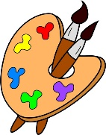
Crofton Junior School – Art Knowledge Organiser – It’s All Greek to Me! – Year 6 Autumn Term

Unit of Work | Art – It’s All Greek to Me! – Mosaic – Antoni Gaudi
Text Driver the Unit of Work Links to | Who Let the Gods Out?
Key Strand | Develop Ideas  Master Techniques – Collage  Take Inspiration from the Greats
Overview of the Unit of Work | Pupils will learn about the architect Antoni Gaudi and the buildings: Sagrada Familia, Casa Batllo and Park Guell. They will also learn that Gaudi pioneered a special mosaic design technique called ‘Trencar’ (which is made from broken chinaware and chards of tiles) that is still in vogue and used by a lot of artists today.  Pupils will also collect information, sketches and resources, and present ideas imaginatively in a sketchbook, comment on artworks with a fluent grasp of visual language and develop and imaginatively extend ideas. Additionally, pupils will combine visual and tactile qualities and use ceramic mosaic techniques. Finally, they will give details about the style of notable artists and create an original piece that shows influence and style.
Prior Learning & Vocabulary | During the Spring Term in year 3, the Spring and Summer Term of year 4 and Spring and Summer Term of year 5, the children will have learnt how to collect information, sketches and resources, adapt and refine ideas, explore ideas and comment on artworks using visual language.  Vocabulary: develop, collect, sketch, resources, adapt, refine, explore, visual language, imaginatively, enhance, unexpected, potential, fluent, striking, precise, coiling, overlapping, tessellation, mosaic, montage.
Sticky Knowledge | Pupils will learn:  - How Antoni Gaudi was an architect born in the 1800s in Spain.  - Gaudi pioneered a special mosaic design technique called Trencar that is still in vogue and used by a lot of artists today.  - Laurel True is a modern-day mosaic artist who founded the Institute of Mosaic Art in California.  - To collect information, sketches and resources, and how to adapt and refine ideas as they progress.  - How to explore ideas in a variety of ways and comment on artworks using visual language.  - That they can mix textures including rough, smooth, plain and patterned.  - How to combine visual and tactile qualities  - To use ceramic mosaic techniques.  - To give details about the style of notable artists and create an original piece that shows influence and style.  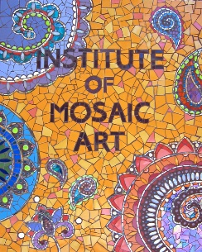  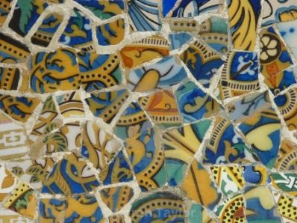  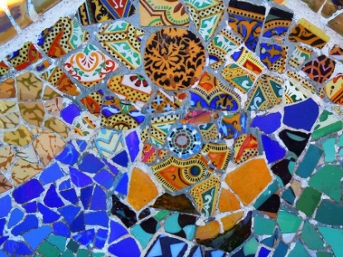  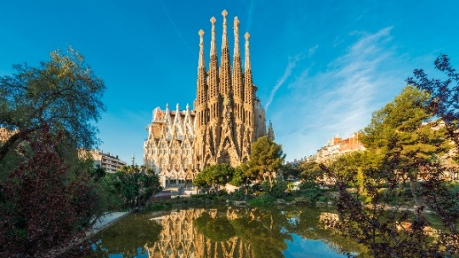  *
End of Unit Outcome | The children will draw upon their knowledge of Ancient Greek mythology to create a mosaic style Greek image based upon a myth of their choice.
New Vocabulary | Tier 2  visual: relating to seeing or sight  tactile: connected with a sense of touch  notable: worthy of attention or notice; remarkable.  influential: having great influence on someone or something  society: the aggregate of people living together in a more or less ordered community.  individualised: tailor (something) to suit a particular individual.  pioneered: develop or be the first to use or apply (a new method, area of knowledge, or activity).  Tier 3  architect: a person who designs buildings and, in many cases, also supervises their construction.  trencar: a mosaic technique created by Antoni Gaudi
Post Learning | Key stage 3  Pupils should be taught to develop their creativity and ideas, and increase proficiency in their execution. They should develop a critical understanding of artists, architects and designers, expressing reasoned judgements that can inform their own work. Pupils should be taught:  - to use a range of techniques to record their observations in sketchbooks, journals and other media as a basis for exploring their ideas  - to use a range of techniques and media, including painting  - to increase their proficiency in the handling of different materials  - to analyse and evaluate their own work, and that of others, in order to strengthen the visual impact or applications of their work  - about the history of art, craft, design and architecture, including periods, styles and major movements from ancient times up to the present day

