Crofton Junior School – Curriculum Knowledge Organiser
Unit of Work | Science – Physics – Year 3
Key Strand | Understanding light and seeing
Overview of the Unit of Work | This concept involves understanding how light and reflection affect sight.
Prior Learning & Vocabulary | Year 2 (materials): transparent, opaque, translucent
Sticky Knowledge | 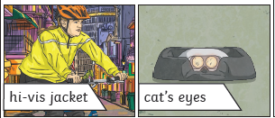  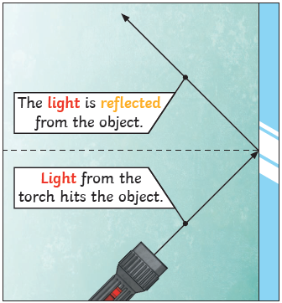  We need light to be able to see things. Light travels in a straight line. When light hits an object, it is reflected. If the reflected light hits our eyes, we can see the object. Some surfaces and materials reflect light well; other materials do not reflect materials well. Reflective materials can be very useful. The surfaces that reflect light best are smooth, shiny and flat.  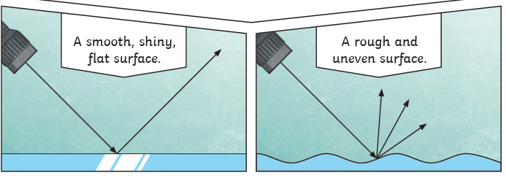 | 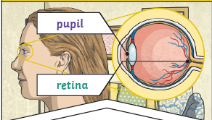  The pupils control the amount of light entering the eyes. If too much light enters, then it can damage the retina. To help protect the eyes, you can wear a hat with a wide brim and sunglasses with a UV rating.
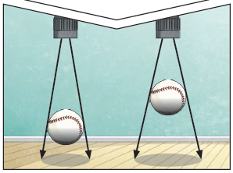
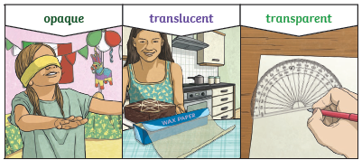
A shadow is caused when light is blocked by an opaque object. When a light source is to one side of an object, the shadow will appear on opposite side.

New Vocabulary | light, light source, names of light sources, dark/darkness, reflect, reflective, mirror, shadow, block, direct/direction, ray, retina, pupil
Post Learning | Year 6 : Light

