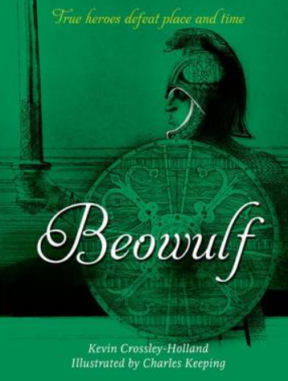
Purpose, Audience and Register
Purpose = The purpose is to write a letter from the perspective of Beowulf to King Hrothgar, outlining his final requests as he heads towards his ultimate battle.
Audience = King Hrothgar is the recipient of the letter.
Levels of Formality = A formal register is required to reflect the fact that Beowulf is addressing a monarch.
Crofton Junior School
English Knowledge Organiser Year 5 Summer Unit 2
Unit of Work | Letter
Text Type / Genre | Non-fiction – Letter
Text Driver the Unit of Work links to | Beowulf – Epic poem retold by Kevin Crossley-Holland

Overview of the Unit of Work including End of Unit Outcome | Pupils will continue the story of Beowulf, reading to the final scenes. They will continue to read a simplified version alongside the main book so that they can fully access the archaic language. Pupils will identify and discuss the key themes as they have developed throughout the story. Pupils will study the relationship between Beowulf and Hrothgar and will summarise all that the soldier has done for the King. After this, pupils will recall their grammatical knowledge of the use of relative clauses, devices to build cohesion and brackets, dashes or commas to indicate parenthesis. They will plan, draft and write their letter by including a summary of Beowulf’s achievements and sacrifices for the King. Children will also select appropriate grammar and vocabulary to understand how such choices can change and enhance meaning. They will then edit and improve their writing to ensure grammatical techniques are used effectively to leave an impression on the King. Finally, pupils will recall their knowledge of proof-reading to allow them to make corrections to errors in spelling, punctuation and grammar.
Links to Reading Objectives | Pupils will continue to read a simplified version of the Beowulf story so that they can fully access the archaic language. Pupils will read to the end of the story which includes the final battle. Pupils will identify and discuss the key themes of the story as they have developed. Furthermore, pupils will understand what they read by asking questions to improve their understanding, predicting, drawing inferences and summarising the main ideas drawn from more than one paragraph. Pupils will discuss and evaluate how authors use of language, including figurative language has an impact on the reader.
Prior Learning | Vocabulary, Grammar and Punctuation Knowledge:  - In Year 5, pupils have started to use devices (such as conjunctions, pronouns and adverbials) to build cohesion within a paragraph.  - In Year 4, pupils used noun phrases expanded by the addition of modifying adjectives, nouns and preposition phrases.  - In Year 4, pupils used fronted adverbials which are adverbial phrases used at the start of sentences. They are followed by a comma.  - In Year 5, pupils have linked ideas across paragraphs using adverbials of time [for example, later], place [for example, nearby] and number [for example, secondly] or tense choices [for example, he had seen her before]  - In Year 5, pupils have explored relative clauses.  - In Year 5, pupils have started to use punctuation to indicate parenthesis (brackets, dashes and commas).
Text Type Features  (Letter) | - A formal letter includes the recipient’s address on the left-hand side and the address of the writer/sender on the right-hand side.  - The date when the letter is written should be included under the address on the right-hand side.  - A formal greeting should be used: Dear Sir/Madam.  - An introduction is needed to outline the purpose for writing.  - The letter should end with a formal closing: Yours faithfully (full name).  - Formal language should be consistently used throughout to reflect writing within the time period that Beowulf is set in.
Sticky Knowledge | During the summer term, time is spent revisiting key sticky knowledge from the autumn and spring terms to embed this knowledge.  The children will learn:  - How authors use language, including figurative language to impact the reader. Pupils will be encouraged to use a range of figurative language features, such as; similes and metaphors  - How to write in role as Beowulf by using language like the author (archaic language) in order to reflect the time period.
New Vocabulary | Archaic – very old or old-fashioned  Recipient – a person or thing that receives or is awarded something  Sacrifice – a person surrendering a possession as an offering  Figurative Language – It is a tool used in literature to help convey an author’s meaning through making comparisons.
Post Learning | - In Year 6, in the spring term, pupils will recall their knowledge of writing a letter by drafting a persuasive letter from Lady Macbeth to Macbeth to encourage him to kill the King of Scotland. This will be inspired by the text: Macbeth.

