Crofton Junior School – Curriculum Knowledge Organiser
Unit of Work | Science – Biology – Year 4
Key Strand | Investigate living things (and their habitats)
Overview of the Unit of Work | This concept involves becoming familiar with a wider range of living things, including insects and understanding life processes.
Prior Learning & Vocabulary | Year 2 (living things): living, dead, move, grow, feed, offspring, habitats (pond, woodland, meadow, ocean, forest, seashore), micro-habitat, damp/wet/dry, dark/light, hot/warm/cold/cool, suited/suitable, basic needs, depend, food, shelter
Sticky Knowledge | To stay alive and healthy, all living things need certain conditions that let them carry out the seven life processes:  - Movement – Respiration – Sensitivity – Growth – Reproduction – Excretion - Nutrition  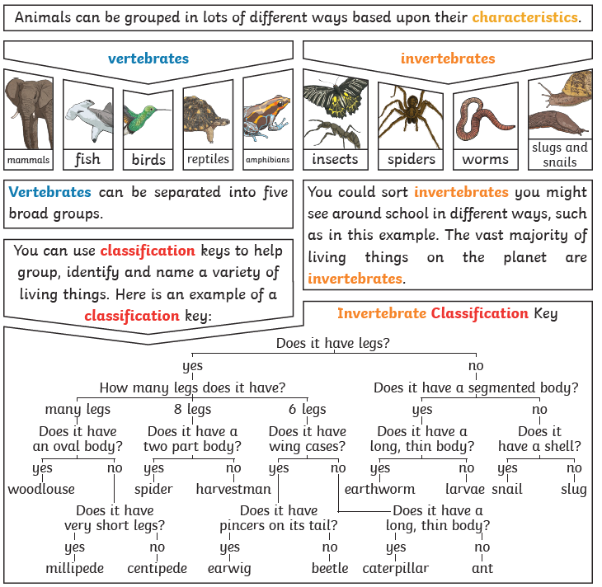  Plants and animals rely on the environment to give them everything they need. Therefore, when habitats change, it can be very dangerous to the plants and animals that live there. Changes to an environment can be natural or caused by humans. Changes to an environment can have positive as well as negative effects.  Here are some examples of things that can change an environment.  natural: - earthquakes – storms – floods – droughts – wildfires – the seasons  human- made: - deforestation – pollution – urbanisation – the introduction of new animals or plant species – creating new nature reserves  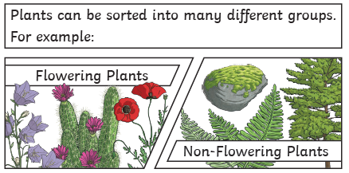
Key Vocabulary | Tier 2  - compare: estimate, measure, or note the similarity or dissimilarity between  - contrast: the state of being strikingly different from something else  - describe: give a detailed account of concepts  - identify: establish or indicate who or what (someone or something) is  - demonstrate: give a practical exhibition and explanation  - recognise: identify from knowledge of appearance or character  - categorise: place in a particular class or group  - classify: arrange in classes or categories according to shared qualities or characteristics  - propose: put forward (a plan or suggestion) for consideration by others  - environment: the surroundings or conditions in which a person, animal, or plant lives or operates  - adaptation: the process of change by which an organism or species becomes better suited to its environment  - impact: the action of one object coming forcibly into contact with another | Tier 3  - classification keys: is a series of questions that determine an organism's physical characteristics  - living things: have a variety of characteristics that are displayed to different degrees: they respire, move, respond to stimuli, reproduce and grow, and are dependent on their environment  - vertebrates: an animal of a large group distinguished by the possession of a backbone or spinal column, including mammals, birds, reptiles, amphibians, and fishes  - invertebrates: an animal lacking a backbone  - fish: a limbless cold-blooded vertebrate animal with gills and fins living wholly in water  - amphibians: a cold-blooded vertebrate animal of a class that comprises the frogs, toads, newts, salamanders, and caecilians. They are distinguished by having an aquatic gill-breathing larval stage followed (typically) by a terrestrial lung-breathing adult stage.  - reptiles: a vertebrate animal of a class that includes snakes, lizards, crocodiles, turtles, and tortoises. They are distinguished by having a dry scaly skin and typically laying soft-shelled eggs on land  - birds: a warm-blooded egg-laying vertebrate animal distinguished by the possession of feathers, wings, a beak, and typically by being able to fly  - mammals: a warm-blooded vertebrate animal of a class that is distinguished by the possession of hair or fur, females that secrete milk for the nourishment of the young, and (typically) the birth of live young  - insect: a small arthropod animal that has six legs and generally one or two pairs of wings  - producer: an organism which does not make its own food but must get its energy from eating a plant or animal or through photosynthesis.  - predator: any animal that hunts and feeds on other animals  - prey: animal that is hunted and eaten by other animals  - energy flow: Primary producers use energy from the sun to produce their own food in the form of glucose, and then primary producers are eaten by primary consumers who are in turn eaten by secondary consumers, and so on, so that energy flows from one trophic level, or level of the food chain, to the next  - flow chart: a diagram of the sequence of movements or actions of people or things involved in a complex system or activity  - habitat: the natural home or environment of an animal, plant, or other organism
Post Learning | Year 5: Living things  Year 6: Living things

