Crofton Junior School – Curriculum Knowledge Organiser
Unit of Work | Science – Biology – Year 4
Key Strand | Understanding animals including humans
Overview of the Unit of Work | This concept involves becoming familiar with different types of animals and the life processes they share.
Prior Learning & Vocabulary | Year 2 (animals including humans): food types, fruit and vegetable, bread, rice, potato, pasta, milk and dairy foods, foods high in fat or sugar, meat, fish, egg, beans, water, food chain  Year 3 (animals including humans): nutrition, nutrients, carbohydrates, protein, vitamins and minerals, fat, dietary fibre, balanced diet, skeleton, muscles, support, protection, movement, skull, ribs, spine/vertebra, joints, sockets, bones, tendons, healthy
Sticky Knowledge | Digestion is the break down of food so that the nutrients can be absorbed by the body. After being chewed, the food enters the body via the oesophagus (a muscular tube). Once within the stomach, it is broken down by the acids within this organ. The small intestine helps to absorb the required nutrients into the body. The large intestine absorbs water from the remaining waste food and stools are formed. To end the digestion process, the stools are stored in the rectum and leaving the body via the anus. | To help prevent tooth decay:  - limit sugary food and drink  - brush teeth twice daily using fluoride toothpaste  - visit your dentist regularly 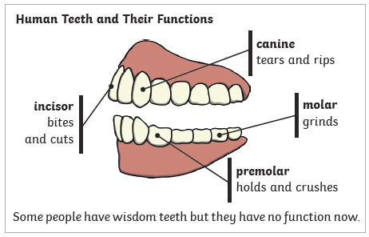
 | 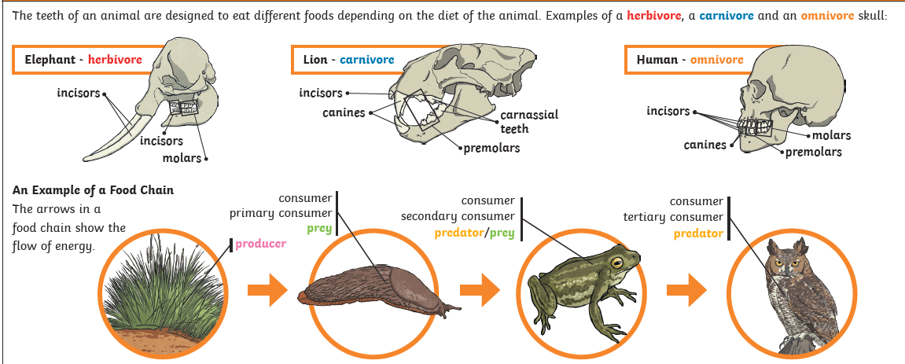
Key Vocabulary | Tier 2  - predict: to estimate that a specified thing will happen  - conclude: arrive at a judgement or opinion by reasoning  - identify: establish or indicate who or what (someone or something) is  - compare: estimate, measure, or note the similarity or dissimilarity between  - categorise: place in a particular class or group  - contrast: the state of being strikingly different from something else  - relationship: the way in which two or more things are connected, or the state of being connected  - similar: having a resemblance in appearance, character, or quantity, without being identical  - propose: put forward (a plan or suggestion) for consideration by others  - label: a classifying phrase or name  - equipment: the necessary items for a particular purpose  - function: an activity that is natural to or the purpose of a person or thing | Tier 3  - digestive system: the organs that take in food and liquids and break them down into substances that the body can use for energy, growth, and tissue repair  - digestion: the process of digesting food - treating a substance with heat, enzymes, or a solvent to promote decomposition or extract essential components  - mouth: the opening and cavity in the lower part of the human face, surrounded by the lips, through which food is taken in and vocal sounds are emitted  - teeth: each of a number of hard, pointed structures in or around the mouth of some invertebrates, functioning in the physical breakdown of food by rip/tear/chew/grind/cut  - enamel: the hard-glossy substance that covers the crown of a tooth  - bacteria: microorganisms which need nutrition from their environment  - canines: a pointed tooth between the incisors and premolars of a mammal, often greatly enlarged in carnivores  - incisor: a narrow-edged tooth at the front of the mouth, adapted for cutting. In humans there are four incisors in each jaw  - molar: a grinding tooth at the back of a mammal's mouth  - pre-molar: a tooth situated between the canine and the molar teeth. An adult human normally has eight, two in each jaw on each side  - saliva: watery liquid secreted into the mouth by glands, providing lubrication for chewing and swallowing, and aiding digestion  - tongue: the fleshy muscular organ in the mouth of a mammal, used for tasting, licking, swallowing, and (in humans) articulating speech  - nutrition: the process of providing or obtaining the food necessary for health and growth  - oesophagus (gullet): the part of the alimentary canal which connects the throat to the stomach  - stomach: the internal organ in which the major part of the digestion of food occurs  - small intestine: the part of the intestine that runs between the stomach and the large intestine  - large intestine: the caecum, colon, and rectum collectively where food waste is formed into excrement, stored, and finally excreted  - rectum: the final section of the large intestine, terminating at the anus  - anus: the opening at the end of the alimentary canal through which solid waste matter leaves the body  - carnivore: an animal that feeds on other animals  - herbivore: an animal that feeds on plants  - omnivore: an animal or person that eats a variety of food of both plant and animal origin  - food chain: a series of organisms each dependent on the next as a source of food  - producer: an organism which does not make its own food but must get its energy from eating a plant or animal or through photosynthesis.  - predator: any animal that hunts and feeds on other animals  - prey: animal that is hunted and eaten by other animals  - consumer: is a living creature that eats organisms from a different population  - independent variable: whose variation does not depend on that of another  - controlled variable: any variable that's held constant in an investigation  - tertiary: third in order or level
Post Learning | Year 6 : animals including humans

