Crofton Junior School – Curriculum Knowledge Organiser
Unit of Work | Science – Physics – Year 4
Key Strand | Understanding electrical circuits
Overview of the Unit of Work | This concept involves understanding circuits and their role in electrical applications.
Prior Learning & Vocabulary | N/A
Sticky Knowledge | Lightning and static electricity are examples of electricity occurring naturally but for us to use electricity to power appliances it is made.  Electricity can be generated by fossil fuels, wind power, solar panels, geothermal and nuclear energy. 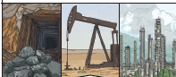 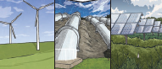 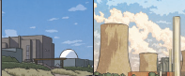  Many appliances rely on electricity whether that be from the mains electricity (socket) or a battery.  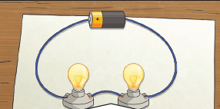  Electricity can only flow around a complete circuit that has no gaps.  A conductor of electricity is a material that will allow electricity to flow through it: metal. An insulator is a material which does not allow electricity to flow through it: wood, plastic and glass.  Switches can be use to open or close a circuit.
 | There are two types of electric current:
 | 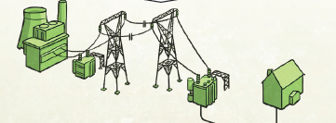  Mains electricity:  Power stations send an electric charge through wires to transformers and pylons. Then, underground wires carry the electricity into our homes via wires in the walls and out through plug sockets. | 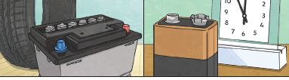  Battery electricity:  Batteries store chemicals which produce an electric current. Eventually, even rechargeable batteries will stop producing an electric current.
New Vocabulary | electricity, appliances/devices, mains, plugs, electrical circuit, complete circuit, circuit diagram, components, cell, battery, positive/negative, connect/connection, short circuit, loose connection, wire, crocodile clip, bulb, bright/dim, switch, buzzer, motor, fast(er)/slow(er), conductor, insulator, metal/non-metal
Post Learning | Year 6 : electricity

