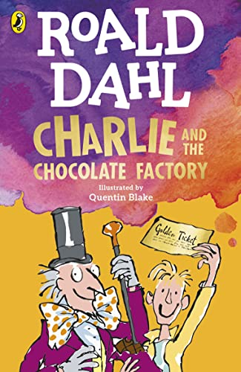
Purpose, Audience and Register
Purpose = The purpose is to invent and then write a description of the final (and undeserving) Golden Ticket winner.
Audience = The audience is a reader of Charlie and the Chocolate Factory.
Levels of Formality = An informal register is required.
Crofton Junior School
English Knowledge Organiser Year 5 Autumn 1 (Unit 1)
Unit of Work | Character Description (Invent a fifth Golden Ticket winner)
Text Type / Genre | Fiction – Character Description
Text Driver the Unit of Work links to | Charlie and the Chocolate Factory

Overview of the Unit of Work including End of Unit Outcome | Pupils will discover the incredible writing of Roald Dahl. They will be immersed in his epic story-telling with a particular focus on the way he describes characters. They will learn how Roald Dahl uses shortcuts such as character names and their appearances to help his audience create first impressions of the characters and their personalities. They will study Chapters 1-9 in depth to learn about the author’s use of language and the key themes that appear in the story. After this, pupils will recall their grammatical knowledge of expanded noun phrases and use their new learning of pronouns and relative clauses in order to write effective and entertaining character descriptions. As the first four Golden Ticket winners are undeserving and unpleasant characters, pupils will invent the fifth and final underserving and unpleasant Golden Ticket winner. They will plan, draft and write their character descriptions using the knowledge of Roald Dahl’s writing style. They will then edit and improve their work to ensure expanded noun phrases, pronouns and relative clauses are used effectively to leave an impression on the reader! Finally, pupils will recall their knowledge of proof-reading to allow them to make corrections to errors in spelling, punctuation and grammar.
Links to Reading Objectives | Pupils will study Chapters 1-9 in depth. They will make predictions and discuss their first impressions of the characters based on their names and appearances. Pupils will identify and discuss key themes in the text (poverty, fairness and family) and how these themes become integral to the story, including how the reader feels about the main characters. Pupils will discuss and evaluate how Roald Dahl uses language to make an impact on the reader, with a particular focus on the first impressions they have once each Golden Ticket winner is introduced.
Prior Learning | Vocabulary, Grammar and Punctuation Knowledge:  - In Year 4, pupils used noun phrases expanded by the addition of modifying adjectives, nouns and preposition phrases.  Text Type – Character Descriptions  - In Year 4, pupils described the Ghost of Christmas Past from the perspective of Scrooge in the autumn term. This was inspired by the text: A Christmas Carol.  - In Year 3, pupils described the appearance of Max the hedgehog in the autumn term as part of a missing poster inspired by the text: The Hodgeheg.  - In Year 3, pupils described the character of Om (a Stone-Age child) from a first-person perspective in the spring term. This was inspired by the text: Stone Age Boy.
Text Type Features  (Character Description) | - A character description is written in an informal style.  - A character description is a passage of text which specifically outlines what your character looks like and details their personality traits too.  - It includes expanded noun phrases in order to describe the character’s appearance and actions.
Sticky Knowledge | During the autumn term, time is spent revisiting key sticky knowledge from previous year groups to ensure this is secure before building on this.  The children will learn:  - When reading, children will learn about “first impressions” and the way Roald Dahl makes specific choices such as character names to help his reader form their first impressions.  - A relative pronoun relates a subordinate or relative clause to the rest of the sentence. The most commonly used relative pronouns are that, which, who and whose. The relative adverbs “where” and “when” can also introduce relative clauses.  - A relative clause is a type of subordinate clause that adds extra information to a main clause. They are usually (but not always) introduced with a relative pronoun: that, which, who, whose, where and when.  - A relative clause can be restrictive (essential) or non-restrictive (non-essential). If it is restrictive, it cannot be left out of the sentence without changing the meaning – it is essential to the sentence. A non-restrictive relative clause adds extra information about the noun which could be left out and the sentence would still make sense. This extra information is separated from the main clause by a pair of commas, brackets or dashes.
New Vocabulary | Impression – a thought, a feeling, an idea or an opinion of someone or something  Poverty – the state of being extremely poor  Relative Clause – a type of subordinate clause (often starting with a relative pronoun) that adds extra information to a main clause  Relative Pronoun - relates a subordinate or relative clause to the rest of the sentence. The most commonly used relative pronouns are that, which, who and whose. The relative adverbs “where” and “when” can also introduce relative clauses.  Omitted – leave out or exclude  Restrictive - essential  Non-restrictive – non-essential
Post Learning | - In Year 5, pupils will describe the character of Grendel as part of a narrative to rewrite the duel between Grendel and Beowulf in the summer term. This will be inspired by the text: Beowulf.  - In Year 6, in the spring term, pupils will describe the character of Lady Macbeth from the perspective of a witch to express her appearance and key characteristics. This will be inspired by the text: Macbeth.

