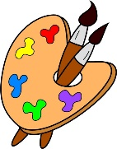
Crofton Junior School – Art Knowledge Organiser – The Rhythm of the Rain – Year 4 Summer Term

Unit of Work | Art – The Rhythm of the Rain – Seascapes – Claude Monet
Text Driver the Unit of Work Links to | When the Mountains Roared
Key Strand | Develop Ideas  Master Techniques – Painting  Take Inspiration From the Greats
Overview of the Unit of Work | Pupils will learn about the art movement ‘Impressionism’ and how it became popular in France in the 19th Century. They will look at impressionist artists such as Pierre Auguste Renoir, Edouard Manet and female artist Mary Cassatt, but then will look specifically at the artist Claude Monet and how he was the founder of Impressionism.  Pupils will also collect information, sketches and resources, adapt and refine ideas as they progress, explore ideas in a variety of ways and comment on artworks using visual language. Additionally they will use a number of brush techniques using thick and thin brushes to produce shapes, textures, patterns and lines, mix colours effectively and experiment with creating mood and use watercolours to produce washed for backgrounds then add detail. Finally, pupils will replicate some of the techniques used by Monet. The pupils will create a seascape painting inspired by Monet.
Prior Learning & Vocabulary | During the Spring Term in year 3, the children will have learnt how to collect information, sketches and resources, adapt and refine ideas, explore ideas and comment on artworks using visual language. They will have also looked at the great artist Wassily Kandinsky and learnt how to replicate his techniques.  Vocabulary: Develop, collect, sketch, resources, adapt, refine, explore, visual language.
Sticky Knowledge | Pupils will learn:  - Impressionism became popular in the 19th Century and impressionists preferred to paint landscapes of everyday life, often depicting people relaxing or showing views of nature.  - Impressionists were called so because they were not trying to create a realistic picture but an ‘impression’ of what the object, landscape or person looked like to them.  - Impressionists believed it was important to capture movement and life and try to show it as if it were happening before our eyes in the painting.  - Monet is described as "the driving force behind Impressionism". Crucial to the art of the Impressionist painters was the understanding of the effects of light on the local colour of objects, and the effects of the colours next to each other.  - To collect information, sketches and resources, and how to adapt and refine ideas as they progress.  - How to explore ideas in a variety of ways and comment on artworks using visual language.  - How to use a number of brush techniques using thick and thin brushes to produce shapes, textures, patterns and lines, mix colours effectively and experiment with creating mood and use watercolours to produce washed for backgrounds then add detail.  - To replicate some of the techniques used by Monet to create a seascape.  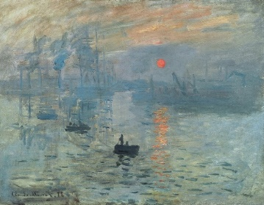  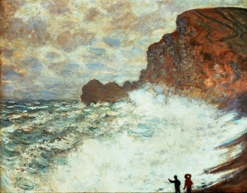  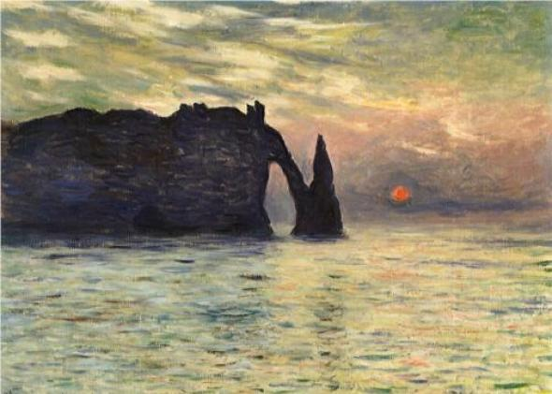  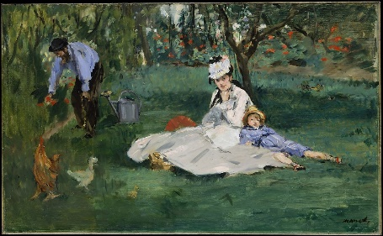  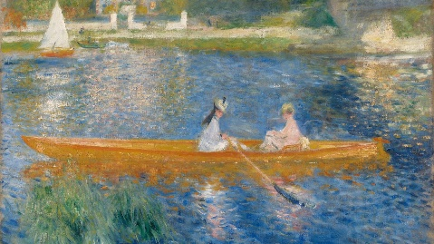  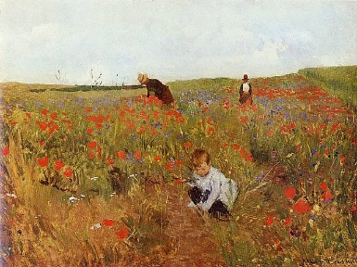
End of Unit Outcome | By the end of the unit of work, children will produce a seascape inspired by Monet using painting skills taken from impressionism.
New Vocabulary | Tier 2  linear: consisting of straight lines  wash: to create a background colour on a canvas  technique: a way of carrying out a particular task, especially the execution or performance of an artistic work  effect: an impression produced in the mind of a person.  compare: estimate, measure, or note the similarity or dissimilarity between  Tier 3  stippling: drawing or painting with dots or light dabs  impasto: paint applied thickly so the brush marks are seen  impressionism: an effect produced in the mind, a vague idea  hatching: drawing with fine, parallel lines to show shading  cross-hatching: like hatching but with two or more sets of parallel lines that cross one another
Post Learning | During the Autumn Term of year 5, pupils will develop and imaginatively extend ideas from starting points throughout the curriculum and spot the potential in unexpected results as work progresses. They will also collect information, sketches, resources, and present ideas imaginatively in a sketchbook and comment on the artworks with a fluent grasp of visual language.  During the Spring Term of year 6, pupils will use painting techniques when looking at the work of Henri Rousseau.

