Crofton Junior School – Curriculum Knowledge Organiser

Unit of Work | Science – Biology – Year 6
Key Strand | Investigate living things (and their habitats)
Overview of the Unit of Work | This concept involves becoming familiar with a wider range of living things, including insects and understanding life processes.
Prior Learning & Vocabulary | Year 2 (living things): living, dead, move, grow, feed, offspring, habitats (pond, woodland, meadow, ocean, forest, seashore), micro-habitat, damp/wet/dry, dark/light, hot/warm/cold/cool, suited/suitable, basic needs, depend, food, shelter  Year 4 (living things): classification keys, environment, insect, fish, amphibians, reptiles, birds, mammals, vertebrates, invertebrates, human impact,  Year 5 (living things): life cycle, reproduction, sexual reproduction, asexual reproduction, germination, pollination, seed formation, seed dispersal, pollen, stamen, stigma, plantlets (E.g. spider plant), runners (e.g. strawberry plant), eggs, live young, gestation, metamorphosis,
Sticky Knowledge | Scientists, called Taxonomists, sort and group living things according to their similarities and differences.  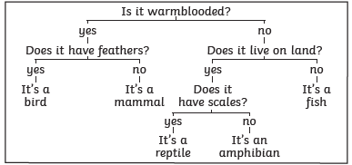  In 1735, Swedish Scientist Carl Linnaeus first published a system for classifying all living things. An adapted version of this system is still used today: The Linnaeus System.  Living things can be classified by these eight levels. The number of living things in each level gets smaller until the one animal is left in its species level. This is how a dog would be classified. | 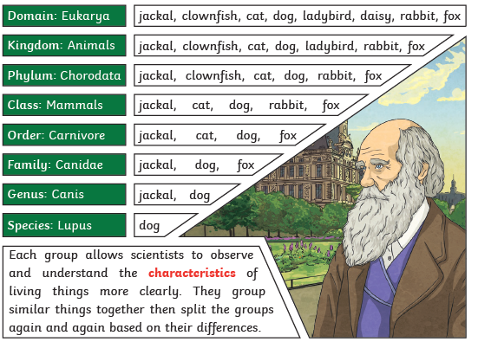
Key Vocabulary | Tier 2  - compare: estimate, measure, or note the similarity or dissimilarity between  - contrast: the state of being strikingly different from something else  - describe: give a detailed account of concepts  - identify: establish or indicate who or what (someone or something) is  - demonstrate: give a practical exhibition and explanation  - recognise: identify from knowledge of appearance or character  - categorise: place in a particular class or group  - classify: arrange in classes or categories according to shared qualities or characteristics  - propose: put forward (a plan or suggestion) for consideration by others  - environment: the surroundings or conditions in which a person, animal, or plant lives or operates  - adaptation: the process of change by which an organism or species becomes better suited to its environment  - impact: the action of one object coming forcibly into contact with another  - justify: show or prove to be right or reasonable  - evidence: the available body of facts or information indicating whether a belief or proposition is true or valid  - debate: argue about (a subject), especially in a formal manner  - label: a classifying phrase or name  - specific: clearly defined or identified | Tier 3  - arachnid: an arthropod of the class Arachnida, such as a spider or scorpion  - mollusc: an invertebrate of a large phylum which includes snails, slugs, mussels, and octopuses  - crustacean: an arthropod of the large, mainly aquatic group Crustacea, such as a crab, lobster, shrimp, or barnacle  - characteristics: a feature or quality belonging typically to a person, place, or thing and serving to identify them  - taxonomist: the science of naming, describing, and classifying organisms  - species: a group of living organisms consisting of similar individuals capable of exchanging genes or interbreeding  - Significant people: Carl Linnaeus: Carl Linnaeus is most famous for creating a system of naming plants and animals
Post Learning | KS3: Material cycles and energy

