Crofton Junior School – Curriculum Knowledge Organiser
Unit of Work | Science – Chemistry – Year 5
Key Strand | Understand materials – Properties and changes of materials
Overview of the Unit of Work | This concept involves becoming familiar with range of materials, their properties, uses and how they may be altered or changed
Prior Learning & Vocabulary | Year 1 Materials: objects, fabrics, materials: wood, plastic, glass, metal, water, rock, brick, paper, elastic, foil, card, rubber wool, clay, hard, soft. Properties: stretchy, stiff, bendy, waterproof, absorbent, breaks/tears, rough, smooth, shiny, dull,  Year 2 Materials: transparent, opaque, reflective, translucent, non-reflective, suitable/unsuitable, rigid, flexible, strong/weak, shape, changed, push, pull, twist, squash, bend, pinch, roll, squeeze  Year 3 Materials: rock, stone, pebble, boulder, soil (sandy/clay/chalky), fossils, grains, crystals, hard/soft, texture, absorb water, permeable, impermeable, marble, chalk, granite, sandstone, slate, peat, igneous, sedimentary, metamorphic, fossilisation, sediment  Year 4 Materials: states of matter, solid, liquid, gas, air, oxygen, powder, grain/granular, change state, ice/water/steam, water vapour, heated, cooled, temperature, degrees Celsius ºC, melt, freeze, solidify, melting point, molten, boil/boiling point, evaporate/evaporation, condense/condensation, water cycle, precipitation, transpiration
Sticky Knowledge | 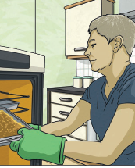  Different materials are used for particular jobs based on their properties: electrical conductivity, flexibility, harness, insulators, magnetism, solubility, thermal conductivity, transparency.  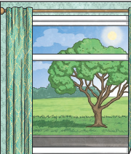  For example, glass is used for windows because it is hard and transparent. Oven gloves are made from thermal insulator to keep the heat from burning your hand.
 | 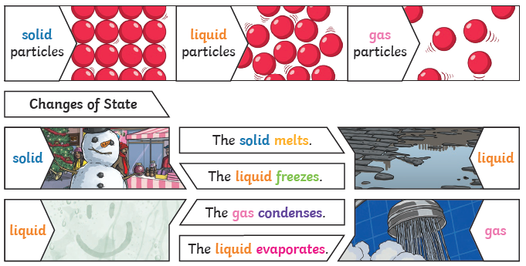 | Reversible changes, such as mixing and dissolving solids and liquids together, can be reversed by…  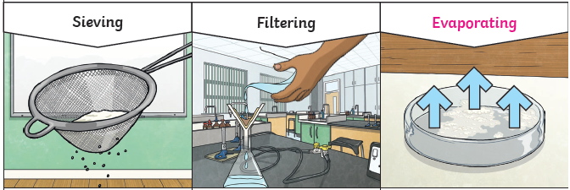
 | Dissolving  A solution is made when solid particles are mixed with liquid particles. Materials that will dissolve are known as soluble. Materials that won’t dissolve are known as insoluble. A suspension is when the particles don’t dissolve.  Examples: Sugar is a soluble material. Sand is an insoluble material. | Smaller materials are able to fall through the holes in the sieve, separating them from larger particles. |  | The solid particles will be caught in the filter paper by the liquid will be able to get through. | The liquid changes into a gas, leaving behind the solid.
 | Irreversible changes often result in new product being made from the old materials (reactants). For example, burning wood produces ash
Key Vocabulary | Tier 2  - describe: give a detailed account of concepts  - compare: estimate, measure, or note the similarity or dissimilarity between  - contrast: the state of being strikingly different from something else  - predict: to estimate that a specified thing will happen  - conclude: arrive at a judgement or opinion by reasoning  - accurate: correct in all details; exact  - label: a classifying phrase or name  - identify: establish or indicate who or what (someone or something) is  - examine: inspect thoroughly in order to determine their nature or condition  - categorise: place in a particular class or group  - contributes: help to cause or bring about  - affect: make a difference to  - extract: remove or take out, especially by effort or force  - investigate: carry out a systematic or formal inquiry to discover and examine the facts so as to establish the truth  - evidence: the available body of facts or information indicating whether a belief or proposition is true or valid |  | Tier 3  - solubility/soluble: the ability to be dissolved, especially in water  - electrical conductivity: the degree to which a specified material conducts electricity  - thermal conductivity: the rate at which heat passes through a specified material  - dissolve: become or cause to become incorporated into a liquid so as to form a solution  - solution: a liquid mixture in which the minor component (the solute) is uniformly distributed within the major component  - insoluble: incapable of being dissolved  - solute: the minor component in a solution, dissolved in the solvent  - solvent: able to dissolve other substances  - particle: any of numerous subatomic constituents of the physical world that interact with each other  - mix/mixture: a substance made by mixing other substances together  - filtering: pass (a liquid, gas, light, or sound) through a device to remove unwanted material  - sieving: put (a food substance or other material) through a sieve to remove unwanted materials  - residue: a small amount of something that remains after the main part has gone or been taken or used  - reversible changes: a change that can be undone or reversed  - irreversible change: if it cannot be changed back again and new materials are always formed
Post Learning | KS3: The nature of matter

