Crofton Junior School – Curriculum Knowledge Organiser

Unit of Work | Science – Biology – Year 3
Key Strand | Understanding animals including humans
Overview of the Unit of Work | This concept involves becoming familiar with different types of animals and the life processes they share.
Prior Learning & Vocabulary | Year 2 (animals including humans): food types, fruit and vegetable, bread, rice, potato, pasta, milk and dairy foods, foods high in fat or sugar, meat, fish, egg, beans, water
Sticky Knowledge | - Living things need food to grow and to be strong and healthy.  - Plants can make their own food, but animals cannot.  - To stay healthy, humans need to exercise, eat a healthy diet and be hygienic.  - Animals, including humans, need food, water and air to stay alive.  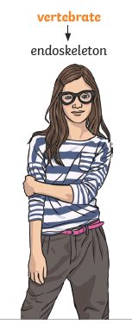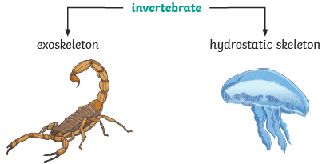  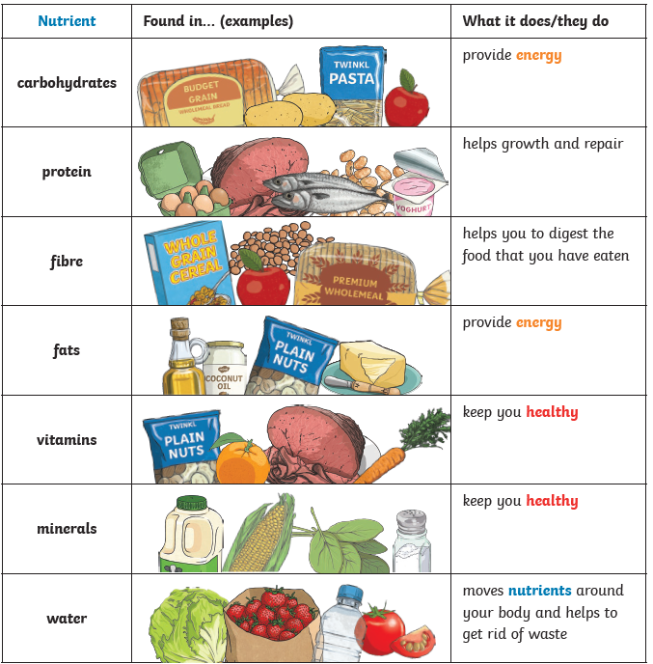 | 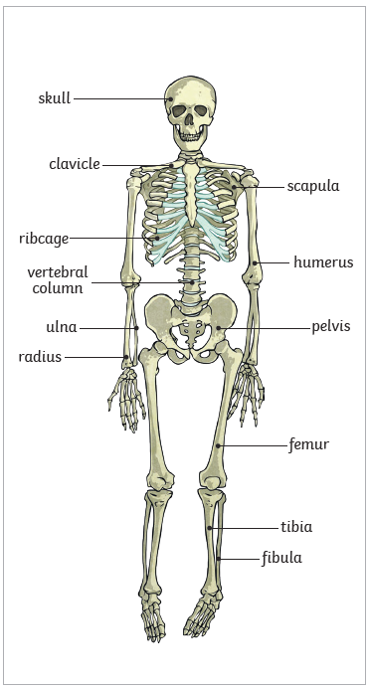  Skeletons do three important jobs:  - protect organs inside the body;  - allow movement;  - support the body and stop it from falling on the floor.  Skeletal muscles work in pairs to move the bones they are attached to by taking turns to contract (get shorter) and relax (get longer).  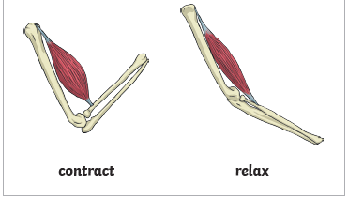
Key Vocabulary | Tier 2  - classify: arrange in classes or categories according to shared qualities or characteristics  - identify: establish or indicate who or what (someone or something) is  - predict: to estimate that a specified thing will happen  - conclude: arrive at a judgement or opinion by reasoning | Tier 3  - healthy : n a good physical or mental condition; in good health  - balanced diet: a diet consisting of a variety of different types of food and providing adequate amounts of the nutrients necessary for good health  - nutrition: the process of providing or obtaining the food necessary for health and growth  - carbohydrates: any of a large group of organic compounds occurring in foods and living tissues and including sugars, starch, and cellulose.  - protein: any of a class of nitrogenous organic compounds which have large molecules composed of one or more long chains of amino acids and are an essential part of all living organisms, especially as structural components of body tissues such as muscle, hair, etc  - vitamins: any of a group of organic compounds which are essential for normal growth and nutrition  - minerals: a solid, naturally occurring inorganic substance  - fat : any of a group of natural esters of glycerol and various fatty acids, which are solid at room temperature and are the main constituents of animal and vegetable fat  - skeleton: an internal or external framework of bone, cartilage, or other rigid material supporting or containing the body of an animal or plant  - muscles: a band or bundle of fibrous tissue in a human or animal body that has the ability to contract, producing movement in or maintaining the position of parts of the body  - support: a thing that bears the weight of something or keeps it upright  - protection: keep safe from harm or injury  - movement: go in a specified direction or manner; change position  - skull: a bone framework enclosing the brain of a vertebrate  - ribs: each of a series of slender curved bones articulated in pairs to the spine (twelve pairs in humans), protecting the thoracic cavity and its organs  - spine/vertebra: each of the series of small bones forming the backbone, having several projections for articulation and muscle attachment, and a hole through which the spinal cord passes  - joints: a structure in the human or animal body at which two parts of the skeleton are fitted together  - sockets: a natural or artificial hollow into which something fits or in which something revolves.  - bones: any of the pieces of hard whitish tissue making up the skeleton in humans and other vertebrates  - tendons: a flexible but inelastic cord of strong fibrous collagen tissue attaching a muscle to a bone.
Post Learning | Year 4 : animals including humans  Year 6 : animals including humans

